

Introduction to

Static Analysis Using

SolidWorks Simulation

®

Radostina V. Petrova

Introduction to

Static Analysis Using

SolidWorks Simulation®

Introduction to

Static Analysis Using

SolidWorks Simulation®

Radostina V. Petrova



CRC Press

Taylor & Francis Group

6000 Broken Sound Parkway NW, Suite 300 Boca Raton, FL 33487-2742

© 2015 by Taylor & Francis Group, LLC

CRC Press is an imprint of Taylor & Francis Group, an Informa business

No claim to original U.S. Government works

Version Date: 20140514

International Standard Book Number-13: 978-1-4822-3619-4 (eBook - PDF)

This book contains information obtained from authentic and highly regarded sources. Reasonable efforts have been made to publish reliable data and information, but the author and publisher cannot assume responsibility for the validity of all materials or the consequences of their use. The authors and publishers have attempted to trace the copyright holders of all material reproduced in this publication and apologize to copyright holders if permission to publish in this form has not been obtained. If any copyright material has not been acknowledged please write and let us know so we may rectify in any future reprint.

Except as permitted under U.S. Copyright Law, no part of this book may be reprinted, reproduced, transmitted, or utilized in any form by any electronic, mechanical, or other means, now known or hereafter invented, including photocopying, microfilming, and recording, or in any information storage or retrieval system, without written permission from the publishers.

For permission to photocopy or use material electronically from this work, please access www.copyright.com (http:// www.copyright.com/) or contact the Copyright Clearance Center, Inc. (CCC), 222 Rosewood Drive, Danvers, MA 01923, 978-750-8400. CCC is a not-for-profit organization that provides licenses and registration for a variety of users. For organizations that have been granted a photocopy license by the CCC, a separate system of payment has been arranged.

**Trademark Notice:** Product or corporate names may be trademarks or registered trademarks, and are used only for identification and explanation without intent to infringe. **Visit the Taylor & Francis Web site at http://www.taylorandfrancis.com and the CRC Press Web site at http://www.crcpress.com**

To my loving family

# CONTENTS

Foreword ............................................................................................................................xi

Preface ............................................................................................................................. xiii

Acknowledgments ............................................................................................................xv

Author ............................................................................................................................ xvii

Chapter 1

Introduction ........................................................................................................................1

1.1 Objectives of the Book .....................................................................................1

1.2 Basics Concepts of FEM ...................................................................................1

1.3 Basic Steps of All Engineering Software, Based on FEM ...............................2

1.4 SW Simulation as a Package for FEA ...............................................................3

Chapter 2

Development of a Finite Element Model of a Body (Pre-Processor Stage) .....................5

2.1 Description of Functions of Physical Model ....................................................5

2.2 Development of the Geometrical Model in SolidWorks .................................6

2.3 Some More Perquisite Knowledge before Development of

SW Simulation Model ...................................................................................... 15

2.3.1 Main Features of Linear Static Analysis ............................................. 15

2.3.2 Starting SolidWorks Simulation..........................................................16

2.3.2.1 Activate SW Simulation Toolbox .........................................16

2.3.2.2 Open the CAD Model .........................................................17

2.3.2.3 Getting Access to Help Files ...............................................18

2.4 Introducing the Material of the Body ............................................................26

2.4.1 How SW Simulation Handles Material Properties ............................26

2.4.2 Defining the Material of the Chisel ...................................................30

2.5 Introducing the Fixtures to the Body ............................................................31

2.5.1 Different Fixtures Supported by SW Simulation ...............................31

2.5.2 Defining the Fixtures to the Chisel ...................................................37

2.6 Introducing the Loads to the Body ................................................................39

2.6.1 Different Structural Loads, Which Can Be Introduced by

SW Simulation.....................................................................................39

2.6.2 Defining the Loads to the Chisel .......................................................43

*Contents*

Chapter 3

Development of a Finite Element Model of a Body (Processor Stage) .........................49

3.1 How Does Finite Element Analysis Work? ....................................................49

3.2 What Are the FEs and the Mesh? ...................................................................50

3.3 Meshing of the Analysed Body ......................................................................58

3.4 Running the FEA .............................................................................................60

Chapter 4

Visualising and Systematising the Results of FEA (Post-Processor Stage) .....................65

4.1 Setting the Analysis and the Results Preferences ..........................................65

4.2 Different Ways to Systematise and Plot the Results of FEA ..........................75

4.2.1 Results Display through Simulation Advisor .....................................75

4.2.2 Results Display through Results Folder in the Analysis Tree ...........85 4.2.3 Results Display through Icons on the SW Simulation

Command Bar .................................................................................. 111

4.3 Listing the Results of the Analysis ............................................................... 117

4.4 Drawing Graphs of the Analysis Results .....................................................123

Chapter 5

Impact of Mesh Density and Viewing Mode on Final Results .....................................129

5.1 Different Types of FEs, Regarding the Geometry of the Model .................129

5.2 Impact of Mesh Density, When Standard Solid Mesh Is Used ...................132

5.2.1 Coarse Mesh Calculations ................................................................132

5.2.2 Fine Mesh Calculations .................................................................... 135

5.2.3 Control Mesh Calculations ...............................................................137

5.2.4 Comparison of Results and Conclusions ......................................... 142

5.3 Impact of Mesh Density, When Curvature-Based Solid Mesh Is Used ......146

5.3.1 Development of CAD Model of Hole Puncher ...............................146

5.3.2 Development of Hole Puncher Model – Pre-Processor Stage ........148

5.3.3 Coarse Mesh Calculations ................................................................ 150

5.3.3.1 Scenario 1 .......................................................................... 150

5.3.3.2 Scenario 2 .......................................................................... 151

5.3.4 Fine Mesh Calculations .................................................................... 153

5.3.5 Control Mesh Calculations ............................................................... 155

5.3.5.1 Scenario 3 .......................................................................... 155

5.3.5.2 Scenario 4 .......................................................................... 158

5.3.6 Comparison of Results and Conclusions for

Curvature-Based Mesh .....................................................................160

5.4 Impact of Mesh Density on Calculation Time and Accuracy .....................163

5.5 Comparison between the Node Mode and the Element Mode .................. 165

5.6 Final Recommendations on Selection of Mesh Type .................................. 165

Chapter 6

Static Analysis of Solid Body with Circular or Planar Symmetry ................................ 167

6.1 Development of CAD Models of the Analysed Bodies ............................... 167

6.1.1 Geometrical Model of a Body with Circular Symmetry ................. 167

6.1.2 Geometrical Model of a Body with Planar Symmetry ...................177 6.2 Static Analysis of the Designed Symmetrical Machine Unit with

Circular Symmetry ........................................................................................189

6.2.1 Why Use Symmetry and How It Works ..........................................189

## viii

*Contents*

6.2.2 Defining the Analysed Segment ...................................................... 191

6.2.3 Static Study of a Body with Circular Symmetry and

Symmetrical Loads ...........................................................................194

6.2.4 Static Study of a Body with Circular Symmetry and

Anti-Symmetrical Loads ...................................................................204

6.3 Static Analysis of the Designed Symmetrical Machine Units with a

Planar Symmetry ...........................................................................................207

6.3.1 Defining the Analysed Segment ......................................................207

6.3.2 Static Study of a Body with Planar Symmetry and

Symmetrical Loads ...........................................................................207

Chapter 7

Static Analysis of a Shell Body ......................................................................................223

7.1 When Can an Object Be Treated as a Shell? Thin or Thick Shell FEs? Different Approaches for FEA of a Shell in SW Simulation ........................223 7.2 Development of a CAD Model of a Shell Using Surface Tool

(Surface.sldprt) ..............................................................................................224

7.3 FEA of a Shell, Created Using Surface Tool (Surface.sldprt) .......................228

7.3.1 Pre-Processor Modelling of the Object ...........................................228

7.3.2 Meshing the Shell .............................................................................232

7.3.3 Viewing the Results ..........................................................................234

7.4 Development of a CAD Model of a Shell Using Sheet Metal Tool

(Sheet_Metal.sldprt) .......................................................................................237

7.5 FEA of the Shell, Created Using Sheet Metal Tool (Sheet_Metal.sldprt) ....244

7.6 Comparison of the Results from the Two Case Studies ..............................246

Chapter 8

Static Analysis of a Frame Body .................................................................................... 251

8.1 Beams or Trusses? ......................................................................................... 251

8.2 Development of a CAD Model of a 3D Frame ............................................254

8.3 Calculation of a 3D Frame of Trusses ..........................................................259

8.3.1 Pre-Processor and Processor Stages ................................................259

8.3.2 Viewing the Results ..........................................................................263

8.4 Calculation of a 3D Frame of Beams ...........................................................265

8.4.1 Pre-Processor and Processor Stages ................................................265

8.4.2 Viewing the Results ..........................................................................271

8.4.3 FE Analysis, When There Are Hinge Connections at Both

Ends of All Beam Members ............................................................. 274

Chapter 9

Static Analysis of a Complex Structure .........................................................................281

9.1 CAD Model of the Studied Structure ...........................................................281

9.2 Static Finite Element Analysis of the Structure ............................................288

9.3 Comparison of the Results of the Sixth Design Scenarios .........................306

9.3.1 Definition of Stress Plots ..................................................................306

9.3.2 Definition of Plots of Inner Beam Forces ....................................... 311

9.3.3 Definition of Displacement Plots ..................................................... 312

9.3.4 Definition of Deformation Plots ...................................................... 314

# FOREWORD

This book on static analysis using the SolidWorks Simulation® tool is written to give a practical problem-based introduction in the use of a finite element simulation approach within a computer-aided design (CAD) tool environment. Nowadays, finite element analysis (FEA) is becoming a versatile approach to analyse complex structures. Contrary to earlier approaches where computer-aided tools were on their own isolated islands of automation, performing design, analysis, simulation and other computerised techniques within a single environment has been found beneficial for several reasons. As a result, we find strong collaborations among developers of today’s computer-aided engineering (CAE) tools.

SolidWorks is one of the advanced and widely used CAD tools in use both in academia and in the industry. Convinced by the benefits of incorporating simulation at early design stage where a designer tests, optimises and simulates the realworld situation without developing costly prototypes, SolidWorks Simulation provides a user-friendly virtual design and prototyping environment. Though the general concept of design simulation using numerical methods is advanced, this book presents an approach where a user can simulate his/her design and gets the feeling of the functionality without deep knowledge of the numerical calculations behind the simulation tool. At the same time, the book attempts to give the basics of the working principles and analysis steps of numerical simulation approaches in general within the simulation examples executed in the book. Therefore, it is the author’s belief that, upon reading the book, the user or the reader gets not only an idea how to use SolidWorks design and simulation functions but also a sufficient level of understanding the working principles of the numerical calculations and the conditions under which the user can make a successful simulation.

The special features of the book are that the user is guided by step-by-step procedures and graphical tools are extensively used to aid easier access to the functions in the software. In addition, key action words are written in bold text. These are mainly intended particularly for new users so that getting used to the graphical user interface and the functionality of the tools is simplified, and the learning curve of new users becomes steep.

The design and simulation principles discussed in the book are further demonstrated in a separate but accompanying solutions manual. Based on the selected 14 case *Foreword*

studies, this book attempts to illustrate design and simulation principles for both simpler and relatively complex cases.

**Hirpa G. Lemu, PhD**

*Assoc iate Professor of Mechan ic al Design En gin eerin g*

*University of Stavanger*

*Norway*

***xii***

# PREFACE

This book is intended to help students and graduates in their first attempts to develop a static analysis of a structure using SolidWorks Simulation®. Complementary, the book can benefit professionals who have initial training in finite element method and are accustomed to the basics of solid mechanics.

The book adopts the SolidWorks software for conducting finite element analysis (FEA) because it is one of the most widely used software packages in mechanical design and related fields. Its features are explained through solving a set of industrial examples, showing different case studies and discussing the impact of the selected options on the result.

After reading the book, students and professionals can independently test their newly acquired knowledge by solving the examples in the attached solution manual.

The development of CAD models is not the focus of the book, but it is a prerequisite for successful understanding of the given samples. Therefore, the readers can either establish the 3D models of the examples themselves, following the instructions in the book and in the solution manual.

The language of the book is easy to follow, granted there are many technical terms; but given the subject, this is inevitable. Any terms that may not be familiar to a practicing engineer or to an engineering student are explained in a way appropriate for undergraduates with little software skills and for inexperienced software users. The adopted ‘step-by-step’ approach, combined with extensive explanatory notes, figures and icons, benefits the understanding of what is being done and guides the readers straight to the next level of performing the FEA. The taught material and what the reader should have learned are summarised after each chapter. Thus, the readers can easily track and assess their progress.

Finally, providing all this knowledge, the book outlines the path that the readers can follow to implement correct and reasonable static analysis, and sets the foundation of their professional improvement in the CAD/CAE field.

Models and images created in this text utilise SolidWorks® and SolidWorks Simulation®. SolidWorks is a registered trademark of Dassault Systemes SolidWorks Corporation, Waltham, MA, USA.

# ACKNOWLEDGMENTS

This book might not have been possible without the strong support of Dr. Gagandeep

Singh, senior commissioning editor for Engineering and Environment Sciences at CRC Press; Mrs. Stephanie Morkert, project coordinator at Taylor & Francis, LLC, who guided my first steps as an author and helped me throughout the entire process of writing this book; Mrs. Marie Planchard, director of education community, SolidWorks, who encouraged me; and my colleagues and friends, who convinced me to share my knowledge and experience.

Last but not least, I would like to thank my family for their patience and love.

# AUTHOR

**Radostina Petrova** has a MSc Eng degree in civil engineering – structural design (calculations) of industrial and residential buildings. She has been working as a structural engineer for few years. Since 2007, she has been a self-employed licensed professional building engineer.

Dr. Petrova received her PhD degree in applied mechanics from the Technical University of Sofia, Bulgaria. In 2003, she was awarded an Ernst Mach research grant for young scientists by the Ministry of Youth, Science, and Education of Austria and adopted the grant at the Vienna University of Technology, Austria, investigating the oscillation of a bi-cable aerial ropeway under lateral wind excitation. She was awarded research grants under the Financial Mechanism of European Economic Area and conducted investigations on the dynamics of a horizontal wind turbine (in 2012) and a robot for medical (surgery) operation (in 2014) at the University of Stavanger, Norway.

In 2007, Dr. Petrova was appointed as associate professor in dynamics, strength and reliability of machines, devices and systems at the Technical University of Sofia.

Dr. Petrova has been recognized as an expert by the Research Executive Agency, Brussels, Belgium; by the National Centre for Research and Development of Poland; and by the Ministry of Education and Science of Bulgaria.

Her research interests and fields of expertise include multi-body dynamic simulation of mechanical systems; nonlinear structural analysis; structural modelling and analysis using FEM; simulation-based, design optimisation of mechanical systems; CAD/ CAE (FEA) design of structures and mechanical systems, particularly dynamic analysis and simulations; structural engineering; wind engineering; fluid–structure interaction; exposure of slender structures (aerial ropeways, wind turbines, etc.) to random dynamic excitation; and interaction and combination of different software platforms/ data for solving different structural problems.

***CHAPTER 1***

# INTRODUCTION

## 1.1 OBJECTIVES OF THE BOOK

The objective of this book is to introduce the basic features of SolidWorks (SW) Simulation through solving a few practical examples. Therefore, we will start our course with trying to answer two main questions:

* Why use the finite element method (FEM)? What are its advantages and disadvantages compared to other numerical methods?
* Why have we chosen SW? Can we use any other software to obtain similar results?

At this very moment, you have to trust and agree with my reasons, but I believe that by the time you finish reading this book, you will have enough knowledge and experience to make your own choice and to find the answers to the above questions. Even more, after reading the book, you should have a good understanding of the logic of finite element analysis (FEA) and the obligatory stages you have to perform when using whatever software to adopt the FEM.

## 1.2 BASICS CONCEPTS OF FEM

There are many numerical methods for modelling, analysing, and simulating different engineering systems or processes. The earliest sources of publications related to FEM could be traced back to the mid-1960s; however, the FEM became popular some decades later with the invention and improvement of computers and the necessary software, and its rise continues up to the present. As used by the modern engineers, FEM represents the confluence of three ingredients: Matrix Structural Analysis (MSA), variation approximation theory, and the digital computer.

Nowadays, the FEM is one of the most widely used techniques for standard designs of engineering objects due to its generality and suitability for computer implementation. Due to the existence of a large amount of software based on FEM concepts and their easy adoption by users with different levels of experience, this software can be found in almost every design bureau, industry department, vocational school and technical university. There is no need to be an expert in the details of the FEM to solve common engineering problems and to handle everyday design tasks.

*In trodu c tion to Static An alysis Usin g SolidWorks Sim ulation*

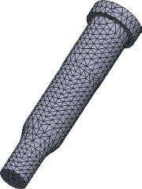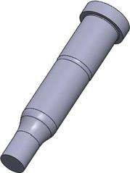

(

a

)

(

b

)

### Fig u r e 1.1

*Models of a hole punch. (a) CAD model of a part. (b) FE model of the same part.*

The principle of the FEM is to slice the solid body into many small, simply shaped cells, which would model the geometry of the body as accurately as possible (Figure 1.1). These small cells are called **finite elements** (FEs) or simply elements. They contact each other at points called **nodes**. The process of transformation of the solid body model into an FE model is called **meshing**, and it is an important step in the FE workflow. It enables the replacement of a complex engineering problem by many simpler bonded problems that have to be solved simultaneously. The software formulates a number of algebraic equations on its own, uniting them in one sparse matrix equation through the connections among the elements, the material properties of the body, the restraints and the loads. The solution of the generated matrix equation governs the behaviour of each FE and consequently relates to the entire body. The final results provide different data for the stress, displacement, strain, temperature, velocity, acceleration, etc. at each separate FE. Therefore, the accuracy of the mesh strongly affects the accuracy of the final solution.

Yet, there is no need for the user to be aware of all mathematical details that form the core of the FEM to successfully reach the correct solution. It is enough for him to be acquainted with some of the basics of FE techniques and their application through a certain program.

## 1.3 BASIC STEPS OF ALL ENGINEERING SOFTWARE, BASED ON FEM

There are a lot of engineering programs that use the FEM to do structural analysis. Some of them are intended to perform different specific analyses and are used in the industry and in science, while others are of a more general level and can be used even by undergraduate students. But all of these software packages have something in common the workflow and the basic stages that have to be performed. The FE software has three main stages that have to be passed through. These are the **preprocessor**, the **processor** and the **postprocessor**. No matter what they are called exactly, their functions within the programs are equivalent.

The user has to create the solid geometry of the body, assign the material properties, impose the displacement or contact boundary conditions and apply external forces in the **preprocessor**. At that level, the knowledge of functioning of the physical models is crucial for finding an accurate solution of the defined engineering problem. That knowledge complemented by a thorough understanding of the logic and the development of FE models leads directly to the final result. The user has to involve his or her

***2***

*In trodu c tion*

entire experience to successfully combine the knowledge of the operation of the physical model to the specifics and perquisites of the finite element model.

The **processor** transforms the development of the preprocessor solid body model into an FE model. Here the software performs meshing (generation of FE mesh) and runs the solution. Its interaction with the user is minimal. In fact, the software generates the core mathematical equations of the FEM almost independently and solves them. It generates all matrixes and arrays regarding the set geometry, material properties, boundary and load conditions, etc. The user can only choose, depending on the program, the size and the type of FE, the type of the used solver and some additional options. However, as a whole, his or her role is passive compared to the active participation in the first (preprocessor) stage. The outcome of the processor is a large dataset, which is systematised by the postprocessor.

The **postprocessor** produces visually or numerically all results. Thus, the user can easily systematise and analyse the data. He or she can verify and modify the model or make some improvements if necessary.

## 1.4 SW SIMULATION AS A PACKAGE FOR FEA

SW Simulation is integrated in some of the SW products, for example, SW Premium, SW Simulation Premium or SW Simulation Professional, enabling the development of an FEA. One of its main advantages is the close interaction between the CAD (geometrical) model and the FE one. In fact, this software is among the best examples of engineering products for CAD/FEA and design. All changes made in the geometry of the studied object are automatically transferred into the FE model, and the software reports that. All performed studies can be saved, duplicated, renamed, etc. They are organised in a tree structure, which can easily be modified.

Another plus of SW Simulation is the existence of **Simulation Advisor** (). It leads the user through the analysis workflow to achieve the final result. It is recommended to be used by users who do not have enough experience either with the method or with the software.

Additionally, there are some more ‘advisors,’ such as Study Advisor, Bodies and Materials Advisor, Interactions Advisor, Mesh and Run Advisor and Results Advisor, which can be activated at different stages of the analysis.

Through his or her work, the user can be connected to a large database with online resources by activating the **Analysis Research** icon (). He or she can **Request License Online** and can be linked to **Simulation Subscription Service** ( ). Even more, the user has a link to the **SolidWorks Simulation Web Site** ( ), where he or she can exchange ideas with other members of **SolidWorks Simulation Community Groups** () or download some files from **SolidWorks Simulation Subscription Support – Download** ().



Different types of analyses can be done using SW Simulation. They include static (or Stress) studies ( ); frequency studies ( ); buckling studies (); thermal studies ( ) ; drop test studies ( ); fatigue studies ( ); nonlinear studies, including nonlinear static study ( ) and nonlinear dynamic studies ( ); linear dynamic studies, including modal time history studies ( ), harmonic studies ( ), random vibration studies () and response spectrum studies ( ); and pressure vessel design studies ().



In this book, we will explain how static studies of simple bodies to more complex structures can be done.

## CHAPTER 2

|  |
| --- |
| ***DEVELOPMENT OF***  ***A FINITE ELEMENT***  ***MODEL OF A BODY***  ***(PRE- PROCESSOR STAGE)*** |

### 2.1 DESCRIPTION OF FUNCTIONS OF PHYSICAL MODEL

We will begin our introduction to SW simulation with a static analysis of a chisel (Figure 2.1).

First, we have to clarify our idea about what chisel is, where it is used and how it works. After that, we continue with the development of the CAD (geometrical) model and its transformation into a finite element (FE) model.

It must be acknowledged that the answers to the previous questions are crystal clear, and because of that, we start the introduction with this cutting tool, which is commonly widespread and familiar to everybody. However, as understanding the operation of a chisel is of significant importance for the development of a correctly

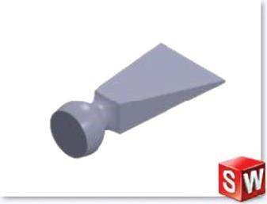

#### Fig u r e 2.1

*CAD model of a chisel, developed in SolidWorks.*

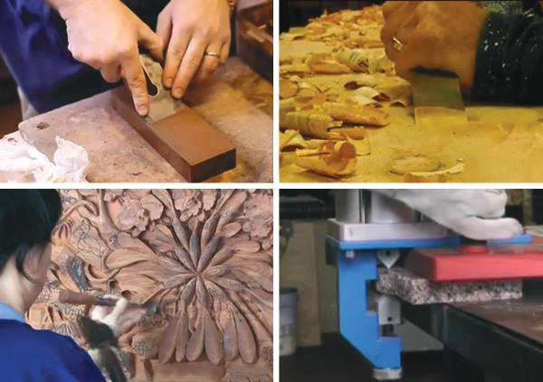

(

a

)

(

b

)

(

c

)

(

d

)

#### Figure 2.2

*How to use a chisel. (a) Guitar building (hand production of musical instruments); (b) woodworking chisel (furniture industry); (c) wood carving; (d) chisel machine “Jaws by Monolit”*

*(stone working industry). (Available at http://www.youtube.com.)*

restrained and loaded FE model, which itself leads to accurate results, we will provide some examples of how chisels can be used. Chisels are an important tool in the woodcarving and woodworking industry, stonework, art design, etc. (Figure 2.2).

Generally, chisels are made of alloy steel. They are fixed at the root and loaded at their opposite sharp edge (the cutting edge). These two basic features of our prototype will help us later in defining restraints and loads.

We studied and clarified how the physical model operates, regarding the materials and restraints.

We know how the studied object functions. We have an idea about its geometry; therefore, we can start the development of the CAD model of the chisel.

### 2.2 DEVELOPMENT OF THE GEOMETRICAL MODEL IN SolidWorks

Having understood how our prototype functions, we must proceed to the next step – development of a CAD model. We can develop a CAD model through whatever software we are accustomed to and then export it in SolidWorks using one of the interchangeable formats such as IGES (*.igs, *iges), STEP (*.step, *.spt), CATIA Graphics (*.cgr), Inventor (*.ipt, *.iam), and Solid Edge (*.par, *.psm, *.asm).

A brief instruction on how to model a chisel is provided in the following.

1. Starting a new file of type *.sldprt:

File →New( ) →New SolidWorks Document → a 3D representation of a single document ( )



The **SolidWorks** working environment is activated. It includes the **Menu bar, Graphics area, SolidWorks Resources** and **Status bar** (Figure 2.3).

There are two groups of commands on the **Menu bar**. The command line menu is visible when the cursor is placed over the bar or the user has clicked the SolidWorks logo. The bar can be kept visible if the user pins it using the drawing pin icon  at the right end of the menu bar. The second group of commands includes the icons of the most commonly used commands. It is always visible, and when the two bands are kept visible, it is situated on the left side of the **Menu bar** (Figure 2.4).

1. Saving the going-to-be-developed CAD model:

File →Save as () → Browsing to displace the file in the working directory → naming the file (Chisel) → Save

The file will be named Chisel to remind us of the prototype. From now onwards, the software will save all geometry data to the file *Chisel.sldprt*. Every time we want to save our model, we can use the **Save** icon () on the

**Menu bar**. We can reload the model through the path

File → Open () → Pick the file (Chisel. sldprt) → Open

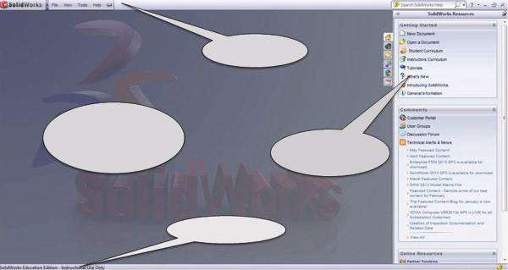

Menu bar

SolidWorks

resources

Graphics

area

Status bar

#### Figure 2.3

*SolidWorks working environment.*

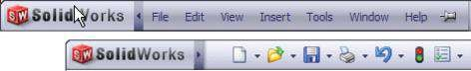Command line menu

Icon line menu

#### Figure 2.4

*SolidWorks Menu bar.*

1. Setting the unit system. It will be SI system: millimetre gram second*.* We will follow the path

Tools → Options→ Document Properties → Units → Unit System (check MMGS) →OK

Pick the command **Tools** from the **Menu bar** (Figure 2.4, Command line menu); pick **Options** () from the pop-down menu; click the **Document Properties** tab of the opened **System Options – General** window; select **Units** from the properties tree; check **MMGS**; and finally click the **OK** button to keep the introduced settings.

1. Drawing a sketch of a square with an edge of 60 mm in the **Front** plane (Figure

2.5f):

To do so, at first, we have to choose the drawing plane:

Sketch tool→Sketch→Front Plane

(a) (b)

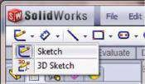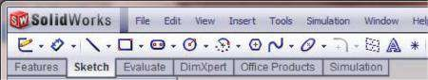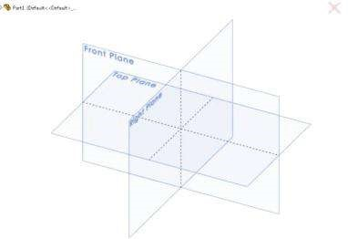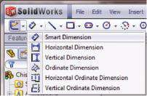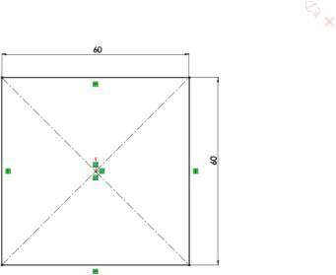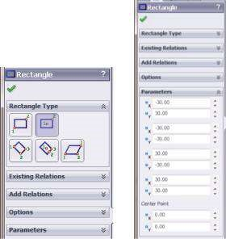

(

c

)

(

e

)

(

f

)

(

d

)

#### Fig u r e 2.5

*Drawing a rectangle. (a) Sketch tool bar; (b) sketch comm and; (c) trim etric view of initial drawing planes; (d) Rectangle property manager; (e) Smart Dimension tool; (f) drawn and dimensioned square.*

We pick the **Sketch tool bar** (Figure 2.5a) and select the **Sketch** command (, Figure 2.5b). The software waits until we pick a drawing plane by clicking on it at the **Graphic Area**. We pick **Front Plane** (Figure 2.5c) for our first **Sketch1**. We sketch the square through the **Center rectangle option** () of the **Rectangle** property manager (Figure 2.5d):

Sketch tool→Sketch →Rectangle →Center rectangle option ()→ OK

Then, we introduce the rectangle dimensions through the **Smart Dimension** tool (, Figure 2.5e). For analysis purposes, it will be OK if we set the **Tolerance/Precision** to zero.

1. Defining a new plane **Plane1**, parallel to the front one at a distance of 25 mm:

Feature tool→Reference Geometry →Plane()→OK

We pick the **Feature tool bar** (Figure 2.6a) and select the **Reference Geometry** command (, Figure 2.6b). From the pop-down menu, pick **Plane** () and input the plane features in the **Plane** property manager – a plane parallel to the **Front** plane at a distance of 25 mm (Figure 2.6c). The newly defined **Plane1** is shown in Figure 2.6d.

1. Drawing a circle of a diameter of 50 mm(Figure 2.7):

Sketch →Circle→Center Circle () →OK

This circle and all onward sketched circles and the square are concentric.

1. Defining **Plane2**, which is parallel to the first two and at a distance of 25 mm from **Plane1**. Sketching a second circle with a diameter of 80 mm(Figure 2.8):

Feature tool→Reference Geometry→Plane()→OK (Figure 2.8a and b)

Sketch →Circle →Center Circle () →OK(Figure 2.8c and d)

(a) (b)

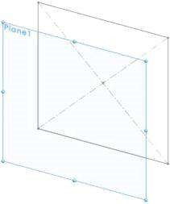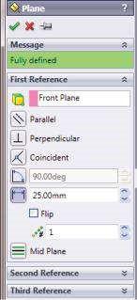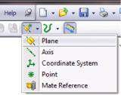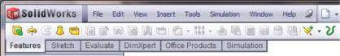

(

c

)

(

d

)

#### Figure 2.6

*Definition of Plane1. (a) Feature tool bar; (b) Reference Geom etry pop-down m enu; (c) Plane property m anager; (d) newly defined Plane1.*

(a) (c)

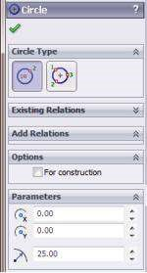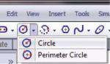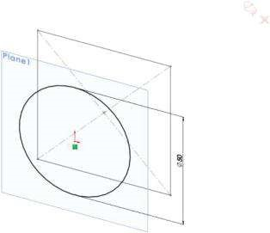

(

b

)

#### Fig u r e 2.7

*Sketching the circle in Plane1. (a) Circle pop-down m enu; (b) Circle property m anager; (c) Circle with a diam eter of 50 mm in Plane1.*

(a) (b)

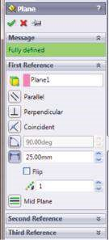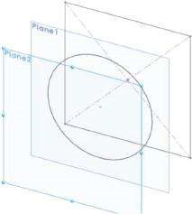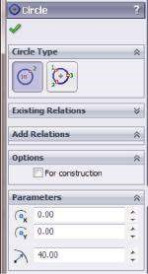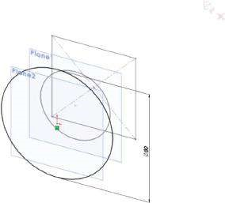

(

c

)

(

d

)

#### Figure 2.8

*Sketching the circle in Plane2. (a) Options of Plane property manager when Plane2 is defined; (b) defined Plane2; (c) Circle property m anager at drawing the circle from stage 7; (d) drawn circle from stage 7.*

1. Defining **Plane3**, which is parallel to the rest of the planes and lies at a distance of 40 mm from Plane2. Sketching the third circle, with a diameter of 80 mm (Figure 2.9):

Feature tool→Reference Geometry →Plane()→OK (Figure 2.9a and b)

Sketch→Circle →Center Circle () →OK (Figure 2.9c and d)

1. Using the Loft feature, we create the root of the chisel (Figure 2.10):

Feature tool→Lofted Boss/Base() →OK (Figure 2.10a)

Right clicking in the blue **Profiles** sub-window of the **Loft** property manager () opens the pop-up menu, shown in Figure 2.10b. We pick the **SelectionManager** to help us in easier selection of the lofted contours. We then push the **Group Selection** button (). Then we select all lines that outline the square (Figure 2.10c) and click the **OK** button of the **SelectionManager**. The signature of the contour is displayed in the blue window. Then we consequently select all circles and confirm each choice by clicking **OK** after each selection. The input properties of the **Loft** property manager are given in Figure 2.10d. Figure 2.10e shows the **Graphic area** view during the introduction of all contours in the **Profiles** sub-window. The green spheres and the dash line connecting them mark the guiding line of the loft. You can try to modify it by simply dragging the green spheres along the profiles. After clicking **OK** () at the **Loft** property manager (), the software displays the lofted root (Figure 2.10f).

The second stage of CAD modelling of the chisel is the creation of its body.

(a) (b) (c) (d)

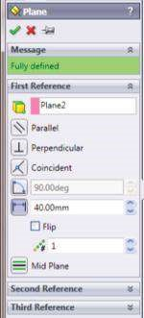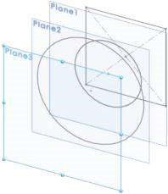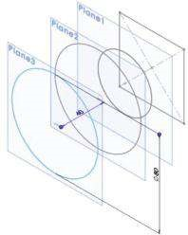

#### Fig u r e 2.9

*Sketching the circle in Plane3. (a) Options of Plane property manager when Plane3 is defined; (b) defined Plane3; (c) Circle property manager at drawing the circle from stage 8; and (d) drawn circle from stage 8.*

(a) (b)

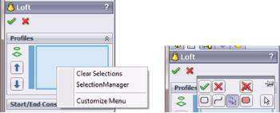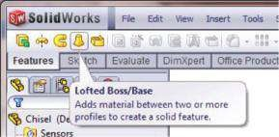

(c) (d) (e) (f)

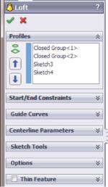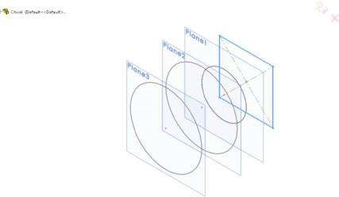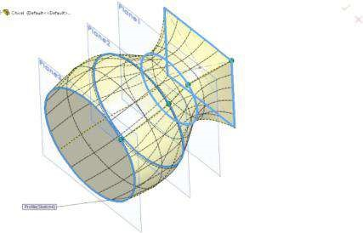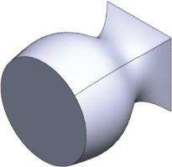

#### Fig u r e 2.10

*Modelling the root of the chisel. (a) Starting Loft Boss/Base command; (b) Selection manager; (c) picking the closed Group1; (d) Loft property m anager with all picked contours; (e) graphic area view after all contours are picked; (f) the geometric model of the root of the chisel.*

1. Definition of a new plane (**Plane4**) on the opposite side of the **Front** Plane at a distance of 200 mm and sketching there a rectangle sized 5/150 mm (Figure 2.11):

Feature tool →Reference Geometry →Plane ()→OK (Figure 2.11a, b and c)

Sketch tool →Sketch →Rectangle →Center rectangle option () →OK (Figure 2.11d and e)

1. Lofting the body of the chisel (Figure 2.12):

Feature tool →Lofted Boss/Base() → OK

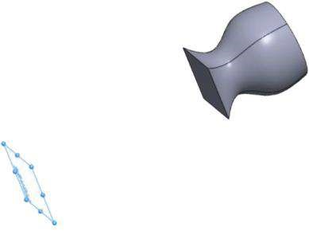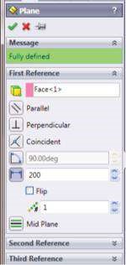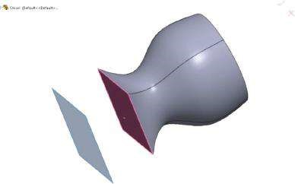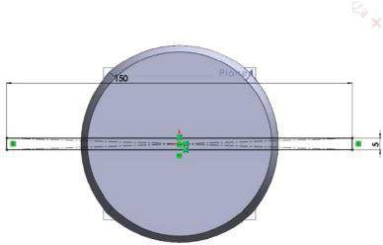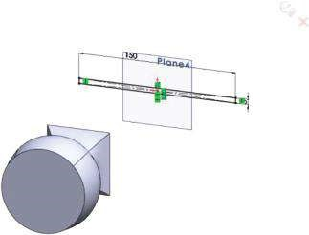

(

)

a

(

b

)

(

)

c

(

d

)(

e)

***Figure 2.11***

*Drawing the sketch, outlining the cutting edge of the chisel. (a) Plane property manager; (b) graphic area view at defining Plane4; (c) graphic area view*

*of the defined Plane4; (d) sketched rectangle, in which the geometric centre is collinear with the geometric centres of the circles (front view); (e) sketched*

*rectangle, which geometric centre is collinear with the geometric centres of the circles (Dimetric view).*

(a) (b)

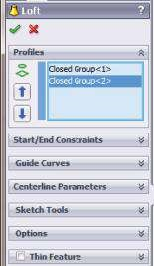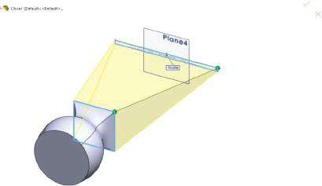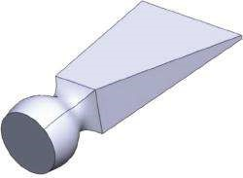

(

c

)

#### Fig u r e 2.12

*Lofting body of the chisel. (a) Loft property manager; (b) graphic area view of the lofted body of the chisel; (c) trim etric view of the chisel.*

Select the **Closed Groups** (Figure 2.12a) using the **SelectionManager**, particularly the **Group Selection** button (), to enable easier selection of the lofted contours. Then select all lines that outline the square and the rectangle (Figure 2.12b) to establish the two **Closed Groups**. Click the **OK** button of the **Loft** property manager to view the ready CAD model (Figures 2.12c and 2.13).

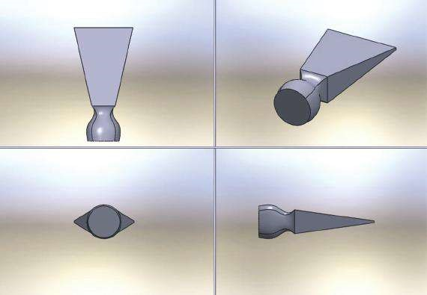

#### Fig u r e 2.13

*Different views of the ready chisel.*

We remembered how a CAD model of a simple part can be drawn. We remind how to start developing a model, how to define the **Unit** system and how to use **Sketch** and **Feature** tools.

|  |
| --- |
| D uring that section, we are reminded how to   * Start developing a CAD model in SolidWorks * Set the Unit system * Sketch simple figures, such as circles and rectangles * D efine new planes * How to feature sketches or contours using Loft Boss/base command |

### 2.3 SOME MORE PERQUISITE KNOWLEDGE BEFORE DEVELOPMENT OF SW SIMULATION MODEL

#### 2.3.1 Main Features of Linear Static Analysis

Finally, we have an idea about the object of our analysis; in fact, we even have the CAD model of our prototype and it seems that we are ready to start. But before proceeding with the analysis, we have to answer one more question: What is the static analysis?

There are several types of analysis that can be made through **SW Simulation**. Static analysis is one of them. It calculates the displacements, strains and stresses in a body or in a structure under the effect of applied external loads (forces, torques, temperatures, gravity, etc.) and with respect to the predefined materials and restraints (fixtures and connections). All of us know that when a body is loaded, it deforms. The effect spreads throughout the whole body. It induces changes in inner forces and reactions and renders the body into something new and totally different from the initial one state of equilibrium. We can make either a linear static analysis or a non-linear one.

This course will teach you how to make a linear static analysis (). Our introduction to linear static analysis will start with the analysis of the chisel. When performing a linear static analysis (), we have to keep in mind the assumptions about the following:

* **Static loading**. This means that all loads are applied slowly and gradually, and when they reach their maximal values, they remain constant. To be more precise, we have to explain that slowly loading means that the time interval for which the load increases its value is larger than one-third of the period of the fundamental frequency of the body.
* **Linearity assumption**. This means that the relationship between the loads and the responses is linear, that is, if we double the values of all loads, the responses (stress, displacement, strain, reactions, etc.) will also double (Figure 2.14a). To validate that assumption, we have to be certain that
* The Hooke’s law is applicable and the stress is proportional to the strain (Figure 2.14b).
* All material properties, such as **Young’s modulus** and **Poisson’s ratio**, remain constant during the analysis.
* The restraints and the loads do not change during the deformation.

The final state of the body does not depend on the consequence of applying the loads.

(a) (b)

Nonlinear

analysis

(σ)

(ε

)

1

E

Nonlinear

analysis

Linear

analysis

Fo

rce

Displacement

##### Fig u r e 2.14

*Functions, describing linearity assumption [SW Simulation On-line Help]. (a) Comparison between linear and nonlinear “ force-displacement” function; (b) Hook’s “strain–stress” diagram.*

#### 2.3.2 Starting SolidWorks Simulation

We are now ready to start our first analysis.

* We know and understand how our object operates; hence, we have enough knowledge to discuss the material, the restraints and the external loads.
* We have a ready CAD model.
* We have a brief idea of the type of analysis we are going to do and the kind of results expected to be received.

To start the SW Simulation tool, we have to pass through some stages, which are described further.

**2.3.2.1 Activate SW Simulation Toolbox** To activate the **SW Simulation toolbox** (Figure 2.15), we have to follow the path

Tools →Add-Ins →SW Simulation →Close

(a) (b)

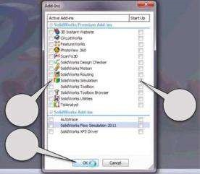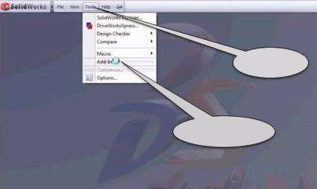

Tools

Add-Ins

1

3

2

##### Fig u r e 2.15

*Commands for activation of SW Simulation. (a) Opening the Add-Ins window; (b) activating SW Simulation toolbox.*

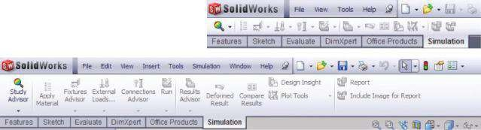Small icons menu

Large icons with text menu

##### Fig u r e 2.16

*SW Simulation command bar.*

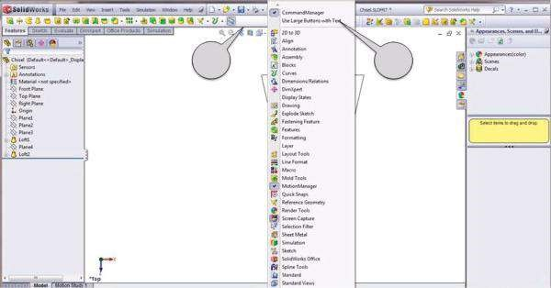

1

2

##### Fig u r e 2.17

*Pop-down menu helping to customize the displayed toolbars.*

When the **Add-Ins** window is opened, you must select the pointed buttons (Figure

2.15b) to

* Activate the SW Simulation toolbox
* Keep it active when SW is started the next time
* Confirm the commands

When the SW Simulation is activated, a new command bar appears below the **Menu bar** (Figure 2.16). Most of the icons are inactive and grey as no analysis is defined yet.

The user can choose to use either large icons or small icons (Figure 2.16). Large icons can be used by right clicking on the command bar and checking the **Use Large Buttons with Text** line on the pop-down menu (Figure 2.17). For beginners, the menu with large icons with text is recommended.

**2.3.2.2 Open the CAD Model** To start the analysis, a CAD model must be opened (Figure 2.18):

File →Open →browse for the file *\*.*sldprt (Chisel.sldprt)

When the CAD model (henceforth, we will call it simply a model) is opened, the working area will look as in Figure 2.19, and we are now ready to start our first FE analysis through SW Simulation.

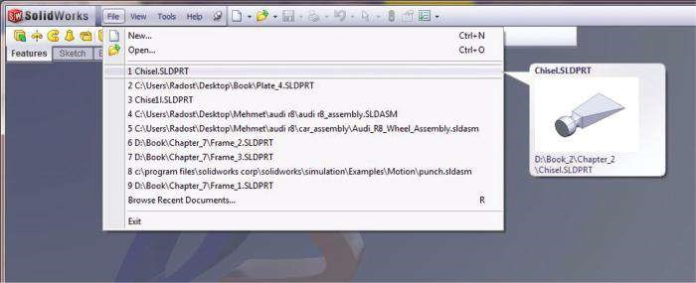

##### Fig u r e 2.18

*How to open an existing CAD model.*

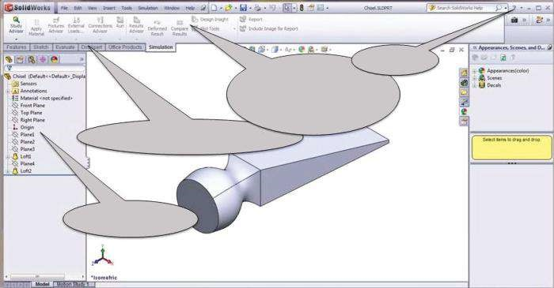

Help

SW Simulation bar

with large icons

Command manager

Design tree

##### Fig u r e 2.19

*CAD model of the chisel – working environment.*

**2.3.2.3 Getting Access to Help Files** At each stage of the analysis, even at the very beginning, you are able to ask for **Help**. As the **SW Simulation** tool is activated and the model is loaded, you have access to some other types of **Help** (Figure 2.20a), particularly focused on simulations. They involve

* **SW Simulation Help Topics**, with some theories on the method and explanations of the functions and options of the commands (Figure 2.20b)
* **SW Simulation Tutorials**, with some examples where each step is carefully explained (Figure 2.20c)
* **SW Simulation Validation**, with some verification problems and National Agency for Finite Element Methods and Standards (NAFEMS) benchmarks (Figure 2.20d)

To start the analysis, you can either click on the **Study Advisor** icon (Figure 2.21) or even simpler on the icon (). As a result, the **Simulation Advisor** () is activated.

(a) (b)

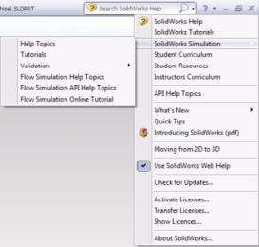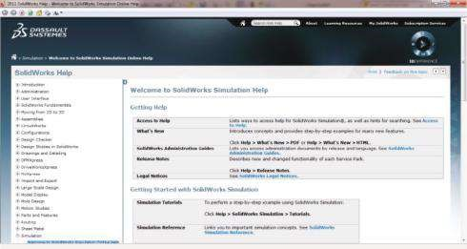

(c) (d) (e)

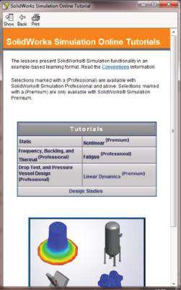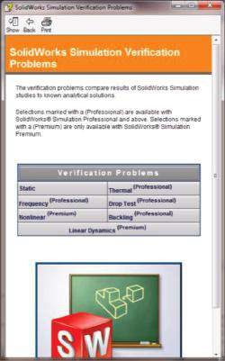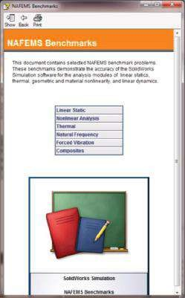

##### Figure 2.20

*SW Simulation help. (a) SW Help; (b) SW Simulation online help topics; (c) SW Simulation tutorials; (d) SW Simulation verification problems; (e) SW Simulation NAFEMS benchmarks.*

This is a window on the right side of the working area (Figure 2.21b). It guides the user through the analysis process, and if you follow the instructions and answer the questions in the window, you will be able to perform your analysis successfully. Meanwhile you will be consulted by all five advisors of the team of the **Simulation Advisor**, which are

* Study Advisor
* Bodies and Materials Advisor
* Interactions Advisor
* Mesh and Run Advisor
* Results Advisor

Additionally, some individual advisors will guide you (Figure 2.21b and c). They can be accessed either through the icons that are situated on the **SW Simulation** bar or through the icons that appear in the simulation model on the left side of the working area (Figure 2.21a). You can see that all icons in the **SW Simulation** bar are highlighted now (Figure 2.22).

(b) (c)

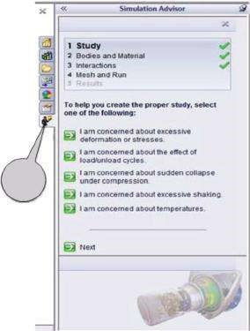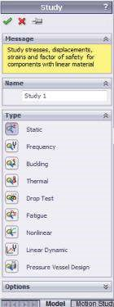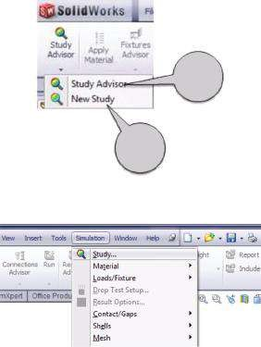

(

a

)

c)

b)

c)

##### Fig u r e 2.21

*Start of a new study and of the individual advisors. (a) Start of a new study; (b) Study advisor; (c) Simulation advisor*.

(a) (b)

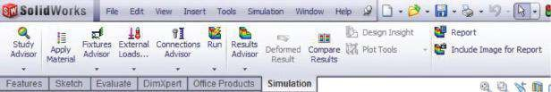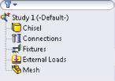

##### Figure 2.22

*SW Simulation individual advisors. (a) At the command bar; (b) at the analysis tree.*

The **Study advisor** and the **Simulation advisor** (Figure 2.21b and c) enable the user to apply the material (), to define fixtures () and external loads ( ), to add connections (), to run the analysis () and finally to systematise the results ( ).



The next step is to choose the type of the analysis and to start it. This can be done by using the **Study** property manager (Figure 2.23). The first stage is to introduce the name of the analysis (1). After that, we choose the type of the analysis (2a), and a brief description of the chosen type of the analysis is immediately displayed by the program in the yellow window in sub-window **Messages** (2b); finally, we can click either the **OK** (3a, ) or **Cancel** (3b, ) icon to preserve or to reject the input properties.

The choice of analysis is significant for “getting the right answers” by the software.

**SW Simulation** performs

* **Static** *(or Stress)* **study** (). It helps to avoid failure due to high stress. Static studies calculate displacements, reaction forces, strains, stresses and factor of safety distribution.
* **Frequency study** (). It helps to avoid failure due to excessive stresses caused by resonance. Frequency studies calculate the natural frequencies and associated mode shapes. It provides information for solving dynamic response problems.

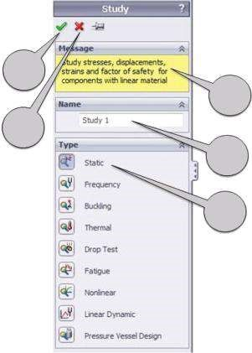

3

a

3

b

2

b

1

2

a

##### Figure 2.23

*How to start a new analysis.*

* **Buckling studies** (). They help to avoid failure due to buckling. It occurs when slender structures are subjected to axial loads and sudden large displacements arise. Usually only the lowest buckling load is of interest, and it is lower than those required to cause material failure.
* **Thermal studies** (). They help to avoid undesirable thermal conditions, like overheating or freezing. Thermal studies calculate temperatures, temperature gradients and heat flow based on heat generation, conduction, convection and radiation conditions.
* **Drop test studies** (). They help to simulate the impact of the model with a rigid planar surface. Drop test studies calculate different parameters of the process to evaluate the effect of a dropping body on a rigid floor.
* **Fatigue studies** (). They help to avoid weakening of the object due to loading and unloading over time even when the induced stresses are considerably less than the allowable stress limits. Fatigue studies evaluate the consumed life of an object, in relation to fatigue events, and based on fatigue calculations on stress intensity, von Mises stresses or maximum principal alternating stresses.
* **Nonlinear studies**, including **nonlinear static study**() and **nonlinear dynamic study** (). They are used to solve problems with nonlinearity caused by material behaviour, large displacements and contact conditions.
* **Linear dynamic studies**, including **modal time history studies**(), **harmonic studies**( ), **random vibration studies**() and **response spectrum studies**( ). They use natural frequencies and mode shapes to evaluate the response of structures to dynamic loading environments.



* **Pressure vessel design studies** (). They combine algebraically using a linear combination or the square root of the sum of squares (SRSS) and the results of static studies under different sets of loads.

Within this course, we are going to perform **Static analyses** () of bodies and structures. Therefore, we click the corresponding icon () and introduce the name of the study, which by default is **Study 1** (1, Figure 2.23) but can be changed to any name that describes the analysis better. It is very important not to forget to click **OK** () or **Cancel** (). This automatically closes the **Study** property manager (Figure 2.23).

The next step is to introduce the properties of the started study (Figure 2.24). We can access the **Study panel** either through the **Study Advisor menu** (Figure 2.24a) or through the **Static analysis tree** by right clicking on the name of the analysis (Figure 2.24b). If we use the **Study Advisor menu**, we must click the **Study Properties** line, or if we open the **Static analysis tree** pop-down menu, we must click **Properties**.

The newly opened **Study properties** dialog window has four different panels, which allow the user to introduce different characteristics of the analysis by choosing options and answering to a set of questions. The **Study properties** dialog window involves four different sub-windows (Figure 2.25).

The first sub-window to be accessed is **Study options** (Figure 2.25a). All properties of the on-going analysis can be introduced through this window. There are some features that the software has already selected. In fact, they are introduced by default; however, the user can change them if necessary. For newly accustomed users, this action is not recommended.

The first tab enables the definition of **Gap/Contact options**:

* **Include global friction***.* This controls the inclusion of the effect of friction for global contact conditions. The software calculates static friction forces by multiplying the normal forces generated at the contacting locations by the friction coefficient, which is introduced through the window on the left and has a value in the range of 0 to 1.0 (0.05 by default).
* **Ignore clearance for surface contact**. This enables considering the contact conditions regardless of the initial distance between user-defined face pairs.
* **Improve accuracy for no penetration contacting surfaces (slower)**. This results in continuous and more accurate stresses in regions with definitions of no penetration contact.

(a) (b)

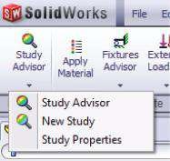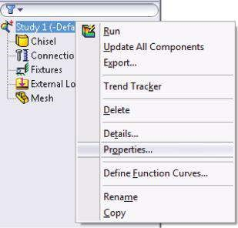

##### Figure 2.24

*Starting the Study properties dialog window. (a) Study Advisor menu; (b) Static analysis tree.*

(a) (b) (c) (d)

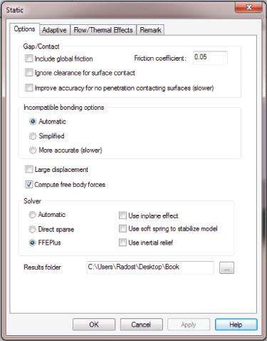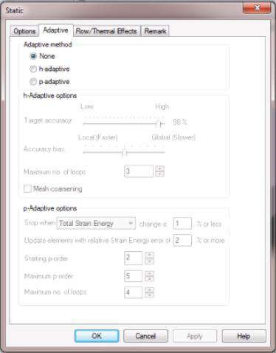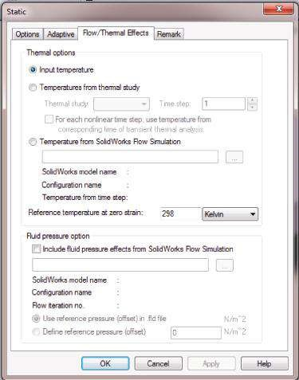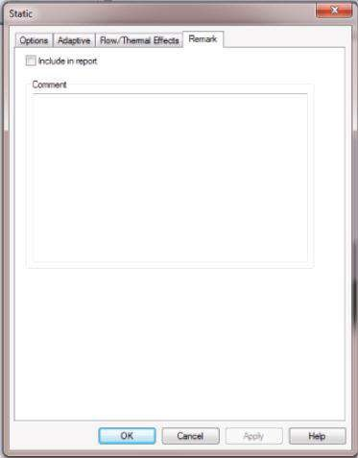

##### Fig u r e 2.25

*Introducing of the Study properties. (a) Study options sub-window; (b) Adaptive options subwindow; (c) Flow/Thermal effects sub-window; (d) Remarks sub-window.*

The second tab on the **Study options** sub-window enables the definition of **Incompatible bonding options**. The user has to choose among three possible approaches of calculation:

* **Automatic**. The default bonding contact is surface to surface, but the solver can switch automatically to node-to-surface bonding contact to accelerate the calculations.
* **Simplified**. This is recommended when solving models with extensive contact surfaces.
* **More accurate (slower)**. The surface-to-surface bonded contact is applied through the entire calculation.

The next step is to choose between

* **Large displacement**: when the program applies the loads gradually and uniformly in steps up to their full values performing contact iterations at every step.
* **Compute free body forces**: the program keeps the force balanced at every node at each node of the FE, including external loads, restraint or contact reactions, etc. This option is chosen by default.

The third tab is the **Solver** tab. In this tab, the user can choose among the following options:

* **Automatic**: the program makes the choice itself. This option is recommended for linear static studies, such as all examples included in the course.
* **Direct Sparse**: it is recommended in cases of multiarea contact problems. It provides satisfying efficiency in speed and memory usage for small problems (up to 25,000 DOFs). When you have enough memory on a computer, the Direct Sparse solver is quicker than the FFEPlus one. Additionally, it is recommended when there are materials varying in wide range material properties, particularly moduli of elasticity.
* **FFEPlus (Fourier Finite-Element Plus)**: it is strongly recommended for solving large problems (over 300,000 DOFs). It is faster than the Direct Sparse solver as the problem gets larger (Figure 2.26).

0

20

40

60

Dire

ct sparse

FFEPlus

FEA solution time

So

lution time (s

ec

onds)

80

100

120

140

0 200,000 400,000 600,000 800,000 1,000,000 1,200,000 Number of degrees of freedom

##### Figure 2.26

*FEA solution time versus number of DOFs. (Available at http://www.javelin-tech.com/blog/2013/01 /which-solver-ffeplus-vs-direct-sparse-part-1/*.*)*

If you choose one of the two solvers, you can control the use of in-plane effect, the use of soft spring to stabilise the model and the use of inertial relief. The **Use** **soft spring to stabilize model** is recommended if the design is unstable, and it is necessary that more restraints be activated to prevent the motion. The flag of that option should not be active by default. The software applies inertial forces to counteract unbalanced external loading when the **Use inertial relief** flag is on. While solving structural problems, this option enables finding the correct solution even if there are not enough restraints and the soft spring option is off.

Finally the user can specify the directory where the simulation results should be stored – **Results folder**.

After choosing all options regarding the purpose of the analysis or keeping them as they are by default, you must click on the **OK button** to save your choice.

The second sub-window sets the adaptive options of the static study and can be accessed through clicking the **Adaptive** tab (Figure 2.25b). Two main adaptive methods, based on error estimation, are used by **SW Simulation** – the **p-method**, which does not change the mesh but increases the FE order to improve the results, and the **h-method**, which refines the mesh but keeps the element order. The **h-method** is recommended for bodies with complex geometry and loading, including sharp corners and concentrated loading. It uses smaller elements in regions with high errors and automatically refines the mesh. The **p-method** increases the FE order, which means an increase in the order of the polynomials used to approximate the displacements. As this is not effective to be done for all elements, the software selects the regions, that is, the selective adaptive p-method is adopted. In this release, the **p-method** does not work with shells and with non-uniform pressure, non-uniform forces or multiple pressures defined on a face.

In the first tab of the **Adaptive** sub-window, the user can choose among the use of no adaptive methods (None button, which is checked by default) and the two adaptive methods.

The **h-Adaptive options** are

* **Target accuracy**: the higher the percentage is, the more accurate the final stress results are, yet the calculation level increases.
* **Accuracy bias**: if the slider is closer to **Local**, the peak stresses are in the focus of the solver, and if the slider is closer to **Global**, the software focuses on the overall stress accuracy.
* **Maximum no. of loops**: sets the maximum number of loops allowed but no more than 5. It is 3 by default.
* **Mesh coarsening**: if the flag is on, the software coarsens the mesh in regions with low error during the adaptive loops.

The software stops calculations based on either of the above defined limits. The **p-Adaptive** **options** are as follows:

* **Stop when**: sets the global criterion for convergence and termination of the loops; can be **Total strain energy** (the sum of the strain energy of all elements); **RMS von Mises Stress** (the root mean square value of the nodal von Mises stresses); or **RMS Res. Displacement** (the root mean square value of the nodal resultant displacements). The **maximum allowable relative change** is set as a percentage.
* **Update elements with relative Strain Energy error xx% or more**: if none of the two stopping criteria defined above are met, the program increases the polynomial order of the elements according to this criterion.
* **Starting p-order**: sets the order to be used for the first loop and varies between 2 and 5.
* **Maximum p-order**: sets the highest p-order to be used. The limit is 5.
* **Maximum no. of loops**: sets the maximum number of loops allowed in the analysis. The limit is 4.

The program stops the loops when one of the above conditions is met.

The third tab of the **Study** property manager is **Flow/Thermal Effects** (Figure 2.25c). If there are no redundant restraints at the body, the changes in temperature cause no additional stresses, but if the body is prevented from free elongation or contraction, the so-called temperature stresses are induced. Consequently, the thermal effects as a consequence of temperature variations have to be studied and added to the stress impact of the loads for all structures with redundant restraints. As this is not our case, we will not discuss this in detail now. It is enough to know that introducing the thermal effects to our analysis can be done through the following options – **Input Temperature; Temperatures from Thermal Study and Temperatures from Flow Simulation**. The same is the situation with the introduction of the **Fluid pressure option**, where the pressure distribution function is input from a **FlowSimulation** results file.

All remarks to the study can be introduced through the **Remark tab** (Figure 2.25d) and will optionally be included in the final report. The desired text is typed in the **Comment** window and is confirmed by clicking the **OK** button.

For the performed static study, it is accepted that all Static analysis properties be left as they are by default, that is

* **Options**: no Gap/Contact options; Automatic incompatible bonding options; Compute free body force; Automatic solver; Results folder – the directory of the open part file.
* **Adaptive**: no adaptive method is selected.
* **Flow/thermal effects**: neither thermal nor flow effects are introduced.
* **Remark**: no remarks.

We summarised all types of the analysis that SW Simulation can perform. We discussed all analysis properties that influence the FE analysis and pointed out the advantages of the options suggested by the program.

|  |
| --- |
| Up to now, we learned how to   * Start SW Simulation tool * Set the type of the analysis * Use the built-in help * D efine properties of the static analysis |

### 2.4 INTRODUCING THE MATERIAL OF THE BODY

#### 2.4.1 How SW Simulation Handles Material Properties

Finally, we have an idea about the object of our analysis. After defining the properties of the analysis or leaving them as they have been defined by the software, it is time to start with the introduction of the model characteristics, particularly materials, fixtures, loads and contacts. **SW Simulation** transfers them directly to the solid body model; hence, they have to be introduced in the pre-processor stage. If they need to be modified later, the software automatically applies the changes, prompts the user and re-meshes the model.

Thus, the model development continues with the definition of the materials. This can be done either by clicking on the **Apply Material** icon () on the command bar or by achieving the command through the analysis tree following the path (Figure 2.27)

Body (right click) →Apply/Edit Material

As a result, a new window opens, where we can either choose a material or define a new one. The definition of a material in SW Simulation does not update automatically the materials assigned to the CAD model.

The **Material** property manager is shown in Figure 2.28.

On the left side of the **Material** property manager, the **Material Tree** is set (Figures 2.28 and 2.29). There are three basic groups of materials: **SolidWorks library materials** are split in **SolidWorks DIN Materials** and **SolidWorks Materials**, and **Custom Materials**. By choosing the last material group, the user can define a new material introducing its name and group as well as its material properties, and later on manage them into a user-defined library.

For non-experienced users, it is recommended to use a pre-defined SW material instead of defining a new one.

For static analysis, we can choose either **isotropic** or **orthotropic material**. The isotropic materials possess the same mechanical and thermal properties in all directions (say, steel), whereas the orthotropic materials demonstrate different mechanical and thermal properties in the three orthotropic directions (say, wood). The assumption of linearity is active for both types of materials.

When defining, choosing or even editing a material, it is necessary to change the data in the **Properties** dialog box (Figure 2.30). It is used to assign the physical properties of the material. The **Model Type** describes the stress–strain relation of the material, and as has been said, only **Linear Elastic Isotropic** and **Linear Elastic Orthotropic** material types are available for static analysis. The **Unit** window sets the unit system in which the values of the material properties are displayed. We shall use the SI system in this

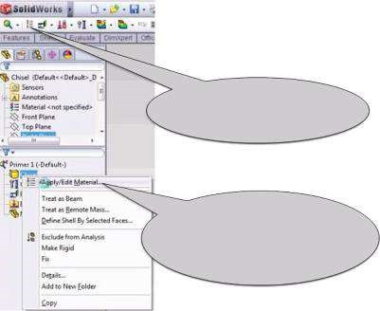

Apply Material icon at

the command bar

Activating Apply

Material command

through the analysis tree

##### Figure 2.27

*Apply Material command.*

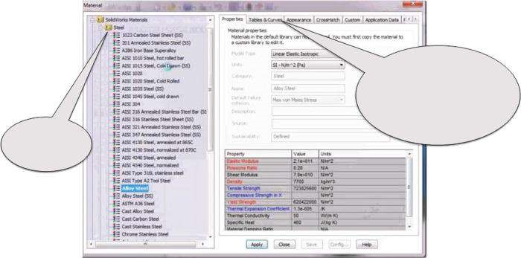

Material

tree

Tabs for defining

the properties of

a new material

##### Figure 2.28

*Material property manager.*

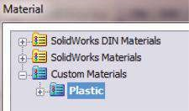

##### Figure 2.29

*Material tree.*

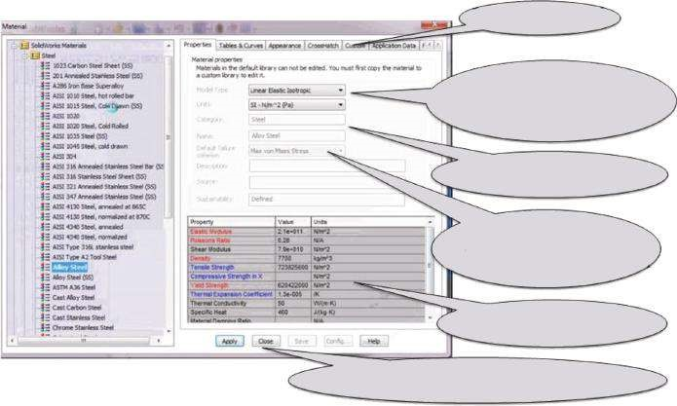

Properties tab

Type of the material

and units

Category and name

How the failure

criteria is calculated

Material properties

Apply, Close, Save, etc. buttons

##### Figure 2.30

*Material property manager – Property window.*

course. After that, the **Category** to which the selected material belongs and its **Name** are introduced. Through the **Default failure criterion**, the user can select which failure criterion to be used when the factor of safety is calculated. In the **Description** window, a free text up to 256 characters can be typed. The **Source** window is active only when a Custom Material is used. The **Sustainability** window indicates if the material has a link to the sustainability database. The **Material Property Table** comes last. It consists of three columns – **Property**, where the material properties are listed and the list depends on the selected material type and the study type; **Value**, where the numerical value of each material property is displayed or input; and **Units** – lists the unit of each material property. Sometimes the **Temp Dependency** column can be added. Material properties, which values are mandatory for static analysis, are coloured in red (elastic modulus, Poisson’s ratio, etc.); those that are optional (tensile strength, compressive strength, etc.) are blue; and those that have values that can be calculated by the program (shear modulus) or are not directly involved in the calculations remain black. The mandatory values and the colouring of the material properties depend on the type of the analysis. The basic material properties are

* **Elastic modulus** (also called Young’s modulus and modulus of elongation): for a linear elastic material, the elastic modulus is equal to the ratio between the stress and the associated strain in that direction. It is obligatory for strain– stress calculations.
* **Poisson’s ratio**: defines the relations between the longitudinal and the lateral strain. For isotropic materials, it is equal in all directions. Poisson’s ratio is a dimensionless quantity.
* **Shear modulus** (also called modulus of rigidity): the ratio between the shearing stress in a plane divided by the associated shearing strain. If a linear isotropic material is chosen, the software can calculate the shear modulus using the values of the modulus of elasticity and Poisson’s ratio. Hence, the value of modulus of rigidity is of no importance for the analysis.
* **Tensile strength.**
* **Compressive strength.**
* **Yield strength.**

These last three material properties are not directly involved in the strain–stress calculations. They are used to calculate the factor of safety or failure criteria. Consequently, depending on the chosen formulae for failure assessment, one of them is coloured in red and the program demands a value.

* **Density**: equals the mass per unit volume. Its colour is red for its value is mandatory when gravity or centrifugal loads are defined.
* **Coefficient of thermal expansion**: defined as change in normal strain per unit temperature and is used in thermal analyses.
* **Thermal conductivity**: the rate of heat transfer through a unit thickness of the material per unit temperature difference.
* **Specific heat**: the quantity of heat needed to raise the temperature of a unit mass of the material by one degree of temperature.

Both previous properties are used in thermal analyses also.

* **Material damping ratio**: used in dynamic analyses; therefore, its value is optional for static analyses.

There are more tabs at the top right of the **Material** property manager.

* **Tables and curves** tab: used to define temperature-dependent curves, that is, the module of elasticity versus temperature, Poisson’s ratio versus temperature, density versus temperature, yield strength versus temperature, etc. They are introduced either by direct input of the data values or by import of the **Curve Data Points File** (*.dat). The function can be visualised.
* **Appearance** tab: used to associate a new colour or texture with the selected material.
* **Crosshatch** tab: used to select the crosshatch pattern associated with the display of the material in section views of drawing documents.
* **Custom** tab: used to add non-standard properties to the material.
* **Application Data**: used to record notes about the selected material.
* **Favorites**: used to manage the material favorites list.

After verification of the material properties, the user must click **Apply** to keep the values and **Close** to close the **Material** dialog box (Figures 2.28 and 2.30).

#### 2.4.2 Defining the Material of the Chisel

For the performed static study, we will use **Alloy Steel**:

SW Materials →Steel →Alloy Steel →Apply →Close

This is a **Linear Elastic Isotropic** material, and all values defining its properties in **SI** units – N/mm2 (MPa) – are (Figure 2.31)

* **Elastic modulus in X** – 210,000 N/mm2
* **Poisson’s ratio in XY** – 0.28 N/A (dimensionless)
* **Shear modulus in XY** – 79,000 N/mm2
* **Mass density** – 7700 kg/m3
* **Tensile strength in X** – 723.83 N/mm2
* **Yield Strength** – 620.42 N/mm2

(a) (b)

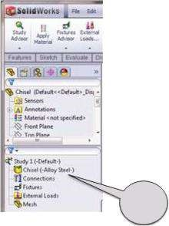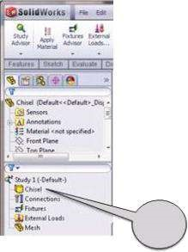

1

2

##### Fig u r e 2.31

*Setting the material of the chisel. (a) SW Simulation analysis tree before setting the material; (b) SW Simulation analysis tree after setting the material.*

We summarised the main properties of linear isotropic materials and discussed how these properties will be involved in further calculations. We pointed out that a new custom material can be defined and added to the existing library of materials.

|  |
| --- |
| Up to now, we learned about:   * Existing SolidWorks libraries of materials * Different material types and properties * How the software grades the importance of material properties considering the type of the analysis * The definition of a new custom material |

### 2.5 INTRODUCING THE FIXTURES TO THE BODY

#### 2.5.1 Different Fixtures Supported by SW Simulation

The third stage in the transformation of the CAD model into a solid body model ready for FE analysis is the inclusion of the fixtures and the definition of more restraints, if there are any (contacts, for example). The fixtures in the SW Simulation tool are fully associative and automatically adjust to every change in the geometry of the model. If a restraint section of the model is deleted or excluded from the analysis, the software immediately reports a problem.

The introduction of the fixtures can be done either through the **SW Simulation** command bar or through the **SW Simulation** analysis tree (Figure 2.22) by clicking on the icon **Fixtures** (). Just as it was when we had to define the material, we can use one of the two ways to activate the **Fixtures** command (Figure 2.32).

Each rigid body can move in six independent manners in the space. Each motion of the body from one point to another can be expressed as a chain of some of these motions without having in mind their consequence. The body can make three translations parallel to the three orthogonal axes and three rotations around these axes.

(a) (b)

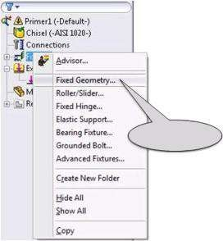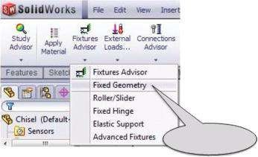

Left click

Left click

##### Fig u r e 2.32

*Defining the fixtures. (a) Defining fixtures through the SW Simulation comm and bar; (b) defining fixtures through the SW Simulation analysis tree.*

Thus, it is assumed that the body has 6 degrees of freedom (DOFs). Adding a restraint or a fixture to the rigid body limiting or stopping its motion along the restricted DOF. When a simple fixture is added, it stops the translation/rotation of the point, and the number of DOFs of the body is reduced by 1. Of course, there are complex fixtures, which limit more than 1 DOF and which are even more widely spread than the simple ones. If enough DOFs are restricted, the body can stay in equilibrium in space, and if it is loaded, only displacements due to its deformations raise. If we have to solve a static problem and the number of the fixtures is equal to 6, the body is steady and the supporting loads/reactions (these are the forces that fixtures apply to the body) can be found through six independent equilibrium equations. If the number of the fixtures is smaller than 6, at least one motion of the rigid body is enabled and it functions as a mechanism. This case will not be discussed here. If the number of fixtures is greater than 6, the body is over-restrained and statically undetermined. The reactions cannot be calculated using simple equilibrium equations, yet the solution is possible to be found. In this case, the geometry and the material of the body have to be considered.

In FEM, fixtures can be applied at each node of the FE. There are two basic types of arrow used by **SW Simulation** to express the type of the fixture (Figure 2.33). The fixture in the left picture (Figure 2.33a) restrains only one translational DOF, while the fixture in the right picture ((Figure 2.33b) restricts all six possible motions. When a simple arrow visualises the fixture, it stops only the translation – one arrow, one translation is set to zero. If the fixture is visualised as an arrow with a disc at its root, it stops the translation along its body as well as the rotation around it. When there are three arrows with discs along the three orthogonal axes, all possible motions are stopped and that node is fixed.

**SW Simulation** uses different symbols to visualise fixtures and loads. It applies green colour to arrows that outline the disposition and the type of the fixtures. Of course, the user can redefine the colour and the size of all used arrows, depending on the model and their personal taste. This change is applicable to all symbols used by SW Simulation, its realisation is explained in the following.

The window **Symbol Settings** (Figure 2.34) is situated at the bottom of the dialog window for defining fixture, load, etc. By default, the size of the symbols is set to 100, but it can be changed easily (Figure 2.34a). If the **Show preview** is checked, the changes appear on the model automatically and are kept by clicking **OK** () or **Cancel** ().

As has been said, the colour of the symbols is green but can be changed by clicking on the **Edit Color** button (Figure 2.34b). The **Color** property manager opens (Figure

2.35). We can choose between **Basic colors** (Figure 2.35a) and **Custom colors** palettes

(a) (b)

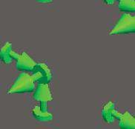

##### Fig u r e 2.33

*Different ways to visualise a fixture. (a) Sliding fixture; (b) steady fixture.*

(a) (b)

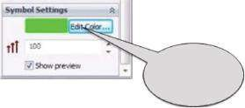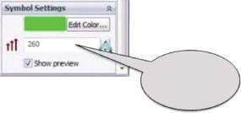

Change

the size

Change

the color

##### Figure 2.34

*Symbol Settings window. (a) Introducing the size of the symbol; (b) introducing the colour of the symbol.*

(a) (b)

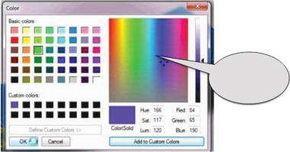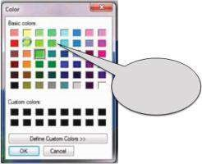

Basic

colors

Custom

colors

##### Fig u r e 2.35

*Colour window. (a) Basic colours palette; (b) custom colours palette.*

(a) (b)

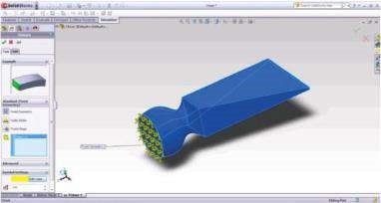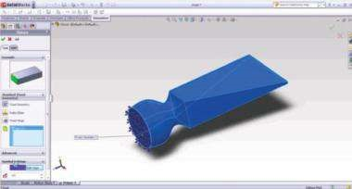

##### Fig u r e 2.36

*Different ways to visualise the fixture symbols. (a) Yellow fixture symbols; (b) violet fixture symbols.*

(Figure 2.35b). Choosing a basic colour is enough to click on the coloured square, and after that, we click **OK**. In the presented example, the colour yellow is chosen (Figures 2.35a and 2.36a).

In Figure 2.36a, the yellow fixture symbols are shown. The new colour of the arrows is updated in the **Symbol Settings** sub-window and is seen on the model (Figure 2.36a).

Sometimes, especially in complex models with a lot of different fixtures/loads, it is recommended to use a custom colour. This is done through the **Color** property manager:

Define Custom Colors →picking the colour →Add to Custom Colors →OK

We have chosen violet as our second option (Red = 84, Green = 65, Blue = 150; Figures 2.35b and 2.36b).

Much more important for each model is the type of the fixture instead of its visual appearance. All fixtures are united in two groups: **Standard (Fixed Geometry)**, involving Fixed Geometry, Immovable Geometry, Roller/Slider and Fixed Hinge, and **Advanced**, involving Symmetry, Circular Symmetry, Use Reference Geometry, On Flat Faces, On Cylindrical Faces and On Spherical Faces. They are directly applied to the solid body model, and in the next stage of the analysis, the software transfers the fixtures to every node of each FE. The basic properties of each fixture can be summarised as follows:

* **Fixed geometry** (, Figure 2.37a). For solid bodies (3D FE) and truss joints (1D FE), this fixture sets to zero all three translations, while for shells (2D FE) and for beams (1D FE), it sets to zero all 6 DOFs. It can be applied to faces, edges, vertices or beam joints. In the **Graphic area**, it is visualised on the model with three arrows with a disk at the end ().
* **Immovable (no translation)** (, Figure 2.37b). It is reached through the **Standard (Fixed Geometry)** property manager, and it is applicable only to shells, beams and trusses. It is not accessible when the model is a solid body. It sets all translations to zero. This fixture can be applied to faces, edges, vertices or beam joints. It is visualised on the model as .
* **Roller/slider** (, Figure 2.37c). This fixture is applicable to planar faces. It sets to zero the motion in direction normal to the face and allows free motion within the plane of the face. It is visualised as  on the model.
* **Fixed hinge** (, Figure 2.37d). This fixture enables the relative rotation of two cylindrical faces. It sets to zero all translations and the two rotational DOFs and frees only the rotation around the axis of the selected cylindrical face ().

The next is the group of **Advanced** fixtures.

* **Symmetry** (, Figure 2.38a). This fixture helps in reducing the model and still obtaining accurate results. The results for the “cut” part of the model are

(a) (b) (c) (d)

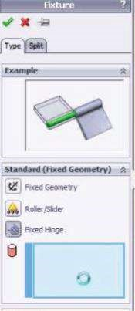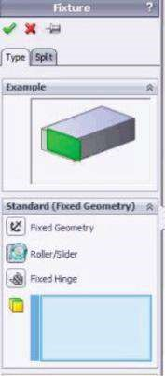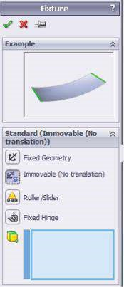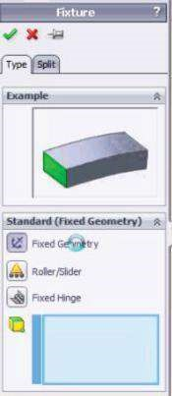

##### Fig u r e 2.37

*Different Standard fixtures. (a) Fixed geom etry; (b) imm ovable (no translation); (c) roller/slider; (d) fixed hinge.*

(a) (b) (c) (d) (e) (f)

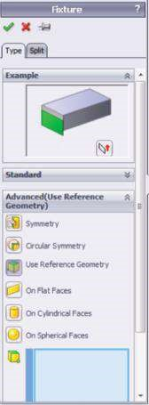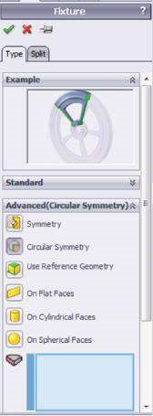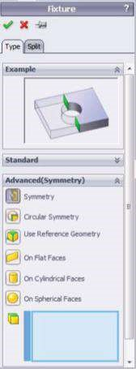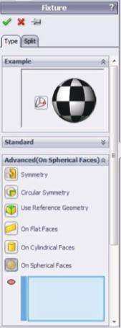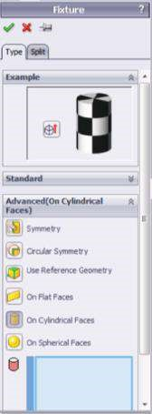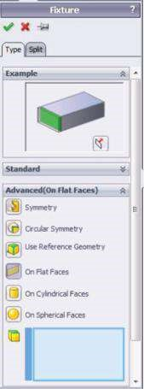

##### Figure 2.38

*Different Advanced fixtures. (a) Symmetry; (b) circular symmetry; (c) use reference geometry; (d) on flat faces; (e) on cylindrical faces; (f) on spherical faces.*

deduced from the ones of the modelled part. If applied, this fixture requires symmetrical consideration about geometry, materials and restraints, including either loads or fixtures. It can be applied to solid bodies and to shells. When applied to a solid body, it restrains only one translation (), and when applied to a shell, it restrains 1 translational + 2 rotational DOFs (). This fixture can be applied only to faces, and this must be kept in mind when working with shells. In such cases, the symmetry fixture restrains the motion in the direction normal to the shell surface as well as rotation about the other two orthogonal axes.



* **Circular symmetry** (, Figure 2.38b). This fixture is used to reduce the size of a circular model by studying a segment of it. The geometry, materials, restraints and loads are similar for all identical segments that form the entire model. The fixture is applicable to faces in solid bodies and is active only in static analysis.
* **Use reference geometry**(, Figure 2.38c). This fixture uses reference geometry to apply restraints. The restrained DOFs depend on the type of the model (solid body or shell); on the reference (model face, reference plane, model edge or reference axis); and on the restraints, which can be applied to faces, edges, vertices and joints. Generally, this fixture restraints for solids – up to 3 translational DOFs ( ); for shells and beams – up to 3 translational and 3 rotational DOFs ( ); and for trusses – up to 3 translations.



* **On flat faces** ( , Figure 2.38d). This fixture is applicable only to flat faces. More than one face can be selected, and each face is restrained according to its own directions. If applied to solids, this fixture restrains up to 3 translational DOFs (), while if applied to shells, it can restrain up to 3 translational and 3 rotational DOFs ( ).
* **On cylindrical faces** ( , Figure 2.38e). This fixture is applied only to cylindrical faces and operates as the **Flat Faces** fixture.



* **On spherical faces** (, Figure 2.38e). This fixture is applied if the selected faces are spherical. It can be applied either to solid bodies or to shells.

A more detailed explanation about the application of the **Advanced** fixtures will be provided in Chapter 6.

Some more fixtures that can easily be accessed through the **SW Simulation** analysis tree are shown in Figure 2.32b. They are not typical fixtures. They define how the selected entity (face, edge or vertex) is connected to the ground, without need of any detailed geometry modelling. They are given as follows:

* **Elastic support** (, Figure 2.39a). It is used to simulate elastic foundations and shock absorbers. It is applied to faces and resists tension and compression. The definition of this connector requires data for its normal and tangential stiffness of the foundation.
* **Bearing fixture** (, Figure 2.39b). It is used to simulate the interaction between a shaft and another rigid shaft or the ground. It can be applied to cylindrical faces, to concentric cylindrical faces of smaller angles of the shaft or to cylindrical shell edges. The fixture enables the adding of self-aligning features to the bearing.
* **Grounded bolt** (, Figure 2.39c). It is used to connect the component (solid body or shell) to the ground. For defining the ground bolt, it is mandatory to define a reference plane. Additionally, the elastic modulus and Poisson’s ratio of the bolt material and its shank diameter are introduced.

Before choosing the type of a fixture, you can choose to apply it to a section of a face instead of to a whole face. This can be done through the **Split** tab, which is situated beside the **Type** tab (Figures 2.37 to 2.39).

(a) (b) (c)

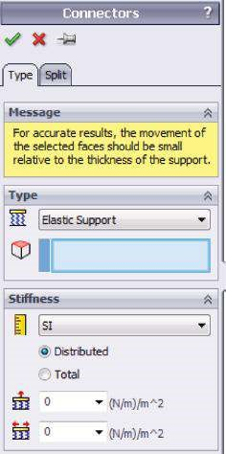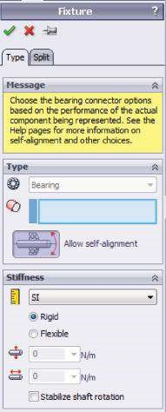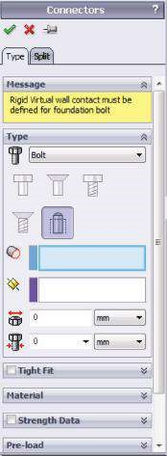

***Fig u r e 2.39***

*Different Connecting fixtures. (a) Elastic support; (b) bearing fixture; (c) grounded bolt.*

#### 2.5.2 Defining the Fixtures to the Chisel

To select the appropriate type of a fixture, you must have an understanding of how the analysed object operates (Figure 2.2). In most cases, the chisel is steadily fixed in the root and loaded at the punching edge. Hence, a **Fixed Geometry** fixture is chosen to be applied to the face in the root of the chisel. The path of commands is described below:

Fixtures(, right click)→Fixed Geometry () →picking the face in the root of the chisel by direct click on it in the Graphics area →OK(, Figure 2.40)

All necessary stages of setting the **Fixed Geometry** fixture are explained in detail later.

Right click the **Fixture** line in **SW Simulation** analysis tree (1, Figure 2.40a).

The **Fixed Geometry** icon is highlighted, that is, the command is active (2, Figure

2.40b). Otherwise, you can simply click on it.

Left click directly in the **Graphics area** at the face where the restraint is applied (3a, Figure 2.40c). The CAD identification of the entity directly appears in the blue window at the left (3b, Figure 2.40c).

Left click on the **OK** icon (, 4, Figure 2.40d) to confirm the command and its options.

The **Fixture** property manager closes.

In this section, we were reminded of the DOFs of the analysed objects depending on the type of the object (a solid body, a shell or a beam) and on the entities attached to the applied restraint and the visualisation of different restraints in the Graphics area. We discussed different fixtures depending on the way they are systematized by the software and how they can be introduced to the studied model.

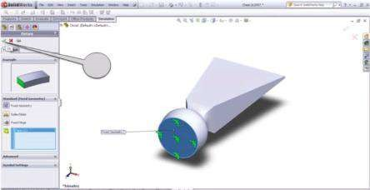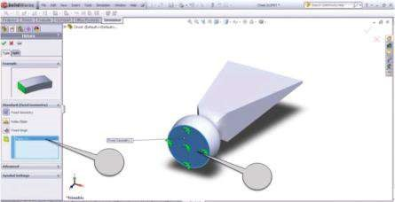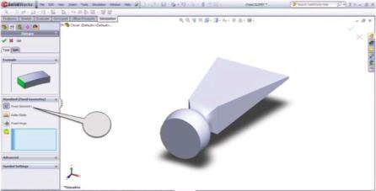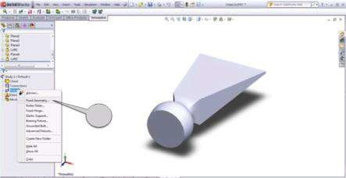

(

)

a

(

b

)

(

)

c

(

d

)

12

4

3

a

3

b

***Figure 2.40***

*Setting a Fixed Geometry fixture at the root of the chisel. (a) Activating the Standard fixture window; (b) choosing a Fixed Geometry command; (c) select*

*-*

*ing the face where the restraint is applied; (d) confirming of the fixture commands.*

|  |
| --- |
| Up to now we learned   * How to introduce a fixture to the model * How to change symbol settings through which the software describes the fixtures and other restraints * The main properties of the fixtures, supported by SW Simulation * How the fixtures are grouped and systematised by the software * What are the mandatory stages of setting a fixture to the studied object |

### 2.6 INTRODUCING THE LOADS TO THE BODY

#### 2.6.1 Different Structural Loads, Which Can Be Introduced by SW Simulation

The fourth and the last stage, which has to be passed through in order to transform the ready CAD model into a model ready for FE analysis, is applying the loads. As far as the FE method is concerned, the loads have a lot in common with the fixtures. The software enables their automatic adjustment to any change in the geometry of the model. They can be introduced to the model either through the **SW Simulation** command bar or through the **SW Simulation** analysis tree (Figure 2.22) by clicking on the icon **Loads** (). There are two ways to activate the **Load** property manager (Figure 2.41).

In general, the loads can be divided in two major groups – **structural loads** and **thermal/flow loads**. As structural loads are directly related to our study analysis, only them will be discussed in detail here. They are given as follows:

• **Force** ( , Figure 2.42a). The forces can be applied to any vertex or point ( ), joint ( ), beam (), edge, face or plane (), and they are easily selected in the **Graphics area** by picking directly over the model. The force can be



(a) (b)

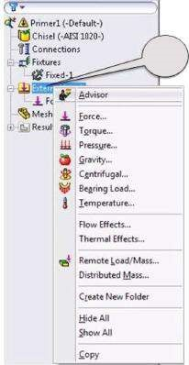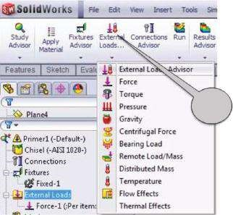

a)

b)

##### Fig u r e 2.41

*Activation of the Load property manager. (a) Activating the Load property manager through SW Simulation command bar; (b) activating the Load property manager through SW Simulation analysis tree.*

(a) (b) (c) (d)

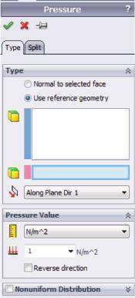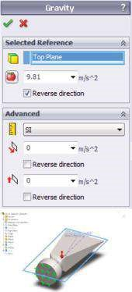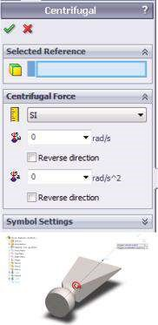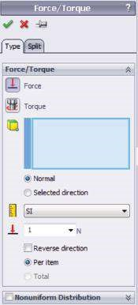

##### Figure 2.42

*Load Property managers – part I. (a) Force/Torque property manager; (b) Pressure property manager; (c) Gravity property manager; (d) Centrifugal property manager.*

**normal** to a face of a solid body or a shell. Then the specified value represents the magnitude of the force. Additionally, **directional forces** can be applied. They act on points, faces, joints, beams, edges and faces. When directional force is applied, it needs a reference mark, which can be an entity (edge or face) or reference geometry (axis for direction or plane). The values of the directional force are introduced by specifying at least one of the following components:

* If the selected entity is a face or a plane – by two tangential ( , ) and one normal () to the entity components



* If the selected entity is an axis – by one radial (), one circumferential

(  ) and one axial () components

* If the selected entity is an edge – the force acts along the edge ( )

When there are some selected entities, the program specifies the value of each definite entity (**per item**) or the **total** value of the force for all selected entities and then distributes the force proportionally among them.

The force can be distributed uniformly or non-uniformly over a face. If the force is non-uniform, a coordinate system can serve as a reference mark. The relative law of the force distribution is a **second-order polynomial** of type

F(x*,* y) = A+ B* x+ C* y+ D* x* y+ E * x2 + F * y2;

where F(x, y) is the relative magnitude of the force applied at a point with coordinates x and y in the selected coordinate system, and A, B, C, D, EandF are polynomial coefficients. When a non-uniform force is applied to a beam, it can be distributed according to a triangular (), a parabolic (), an elliptical () or a table-driven law. If the load reverses its direction along the geometric entity (face or edge), it is recommended to use the **Split** command (to be explained in detail later).

For dynamic studies, the force can vary in time also.

* **Torque** (, Figure 2.42a). The same **Force/Torque** property manager is used. The torque is applied to faces (usually circular or cylindrical faces) or beams, which can be selected either by directly picking them in the **Graphics area** or by clicking them in the floating **SW design tree** in the **Graphics area**. The reference entities can be either an axis or an edge or a cylindrical face. The value of the torque is directly specified in the **Force/Torque** property manager. The torque can be uniformly distributed only.
* **Pressure** (, Figure 2.42b). The pressure can be applied to any face of a solid body or of a shell or to any edge of a shell by clicking directly on it at the model. The pressure can be either normal to the loaded face or in any other direction. If the direction of the pressure is not normal to the face, a reference entity has to be defined. It can be as follows: a planar face or a reference plane, then the pressure component can be tangential ( , ) or normal () to it; a cylindrical face or a reference axis, then the pressure component is either radial () or circumferential () or axial (); an edge ( ) – the pressure acts along the edge and is introduced either as a positive or a negative value.



The pressure can be either uniformly or non-uniformly distributed.

If we apply a **uniform pressure** of a value of pto a face of area A1, the **equivalent force** will be P = p * A1. If the geometry of the face is modified and the area is set to A2, then the value of the equivalent force automatically changes to P = p * A2.

If you prefer to keep that value constant, it is better to apply a force that has a value P. Then even after certain changes in the face geometry, the total value of the force will be preserved.

If a non-uniform pressure is applied, the law is associated with a previously defined reference coordinate system. It is a second-order polynomial p(x, y) = V * (A + B* x + C * y + D * x * y + E * x2 + F * y2);

where p(x, y) is the magnitude of pressure applied at a point with coordinates x and y in the reference coordinate system; V is the value specified in the **Pressure value** field (); and A, B, C, D, E andF are polynomial coefficients.

If the pressure reverses or changes its direction, it is recommended to use the **Split** command.

For dynamic studies, the pressure can vary in time.

* **Gravity** (, Figure. 2.42c). The **Gravity** property manager applies linear accelerations, which distribute over the entire volume of the body. The load value is calculated as the density of the material multiplied by the introduced acceleration. The input values can vary. The directions of the acceleration can be parallel either to the three coordinate axes or to a selected edge. By default, the value of the acceleration is 9.81 m/s2, and it is normal to a preselected plane (see the red arrow in Figure 2.42c).

For dynamic and non-linear analysis, the acceleration can be a time-dependent function.

The software enables the use of distributed/remote masses (to be discussed later).

* **Centrifugal** (, Figure 2.42d). The Centrifugal property manager applies angular velocity and acceleration to the body. The model spins around the specified axis (Axis 1, Figure 2.42d). The software calculates the centrifugal loads based on the specified values of angular velocity () or angular acceleration () and the density of the material. The centrifugal load symbol () is shown at the centre of gravity of the model (Figure 2.42d).

For non-linear analysis, the velocity and the acceleration can be timedependent functions.

Some more structural loads are as follows:

* **Bearing** (, Figure 2.43a). Bearing loads can be applied through the **Bearing** property manager at contacting cylindrical faces or edges of circular shells. The software enables a choice between **sinusoidal** and **parabolic** distribution of the pressure at the interface of contact.
* **Temperature** (, Figure 2.43b). Thermal boundary conditions can be prescribed to faces, edges or vertexes. It is enough to select the entity and to introduce the temperature.

For nonlinear or transient thermal studies, the temperature can vary with time.

* **Flow effects** (Figure 2.25c). To use this command, an **SW Flow Simulation** should be done in advance, and the loading from the output results file can be imported directly from the static analysis performed by SW Simulation.
* **Thermal effects** (Figure 2.25c). The option enables considering the thermal effects in static studies. To guarantee the success of the analysis, it is mandatory to introduce the coefficient of thermal expansion for each material in the model. This effect is worth studying when there is uniform change in the temperature for the whole model, when there is a results file from previously done thermal analysis or from **SW Flow Simulation** and in some other cases.
* **Remote load/mass** (, Figure 2.43c). Remote loads, restraints and masses are used to simplify the model. There are three basic options to define a remote entity:
* **Load (direct transfer)***.* This option is appropriate when the displacements of the suppressed body are small. The location of the load is specified through the coordinates of the point on the global coordinate system or in a user-defined one. The software calculates the loads at all selected entities within the analysed model.
* **Load/mass (rigid connection)***.* It is used to define forces, moments and masses that are suppressed or not defined in the geometric model. The forces and the moments are applied at remote locations. As these remote entities are outside of the model, their coordinates in the initial or in the user-defined coordinate systems introduce them. The function assumes that all geometric entities connected to the remote location act as rigid ones. If the stress–strain distribution is of no interest, the body can be replaced by a remote mass. Then only its effect on the rest of the structure is analysed. The remote mass is situated at the centre of gravity of the suppressed body.
* **Displacement (rigid connection)***.* This option replaces bodies that can be considered as rigid bodies and their displacement is known. The software calculates the effect of that constraint on the rest of the structure assuming rigid bar connections to all pre-selected entities, that is, faces, edges or vertexes.
* **Distributed mass** (Figure 2.43d). This function is used to simulate the effect of bodies that are suppressed or not included in the modelling when their mass can

(a) (b) (c) (d)

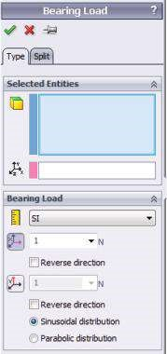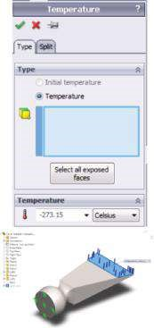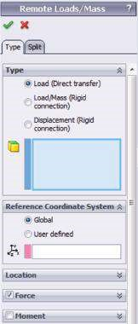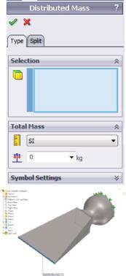

##### Figure 2.43

*Load Property managers – part II. (a) Bearing property manager; (b) Temperature property manager; (c) Remote load/mass property manager; (d) Distributed mass property manager.*

be assumed to be uniformly distributed on the specified faces. It is assumed that the suppressed body lies directly on the selected faces, so rotational effects are not considered. To use that command, either gravity or centrifugal effects should be defined. The software distributes the mass proportionally to the area of all selected faces.

Usually there is more than one structural load applied to the analysed model. As there have been assumed static loading and linear stress–strain distribution, the software superimposes (adds) all pressures, forces and remote loads. On the contrary, the software allows the definition of one gravity and one centrifugal load.

#### 2.6.2 Defining the Loads to the Chisel

Based on the shown applications (Figure 2.2) of the chisel, two types of loading are studied:

* **First scenario**: A pressure load distributed over the cutting face of the chisel
* **Second scenario**: Pressure loads distributed over the cutting edge of the chisel and over a section of its side edge

Detailed explanation of both scenarios is provided further:

* **First scenario** (Figure 2.44). In this scenario, the use of the chisel is similar to the applications shown in Figure 2.2c and d. According to experimental data, this load is non-uniform along the longer edge of the face, because of the existing usually omitted friction forces between the cutting and the cut objects. The use of a parabolic function to define the distribution of normal pressure will guarantee high-enough accuracy of our model.

The external load will be input through the **Force** property manager:

SW Simulation analysis tree →External Loads →Force ()

(a) (b) (c) (d)

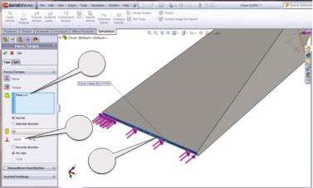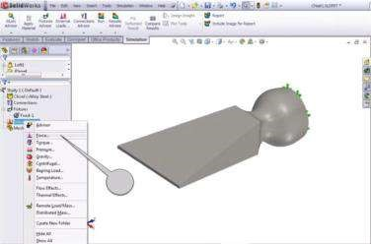

1

2

b

2

a

2

a*

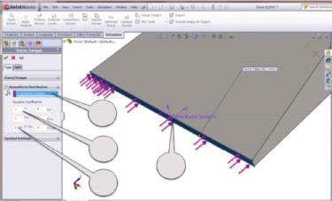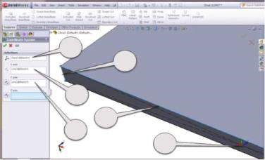

3

c

3

a*

3

b*

3

c*

4

a*

4

a

4

b

4

c

3

a

3

b

##### Figure 2.44

*Introducing a load normal to the cutting face – first scenario. (a) Opening of the Force property m anager; (b) introducing the loaded entity and the direction of the load; (c) definition of a new coordinate system; (d) introducing the load function.*

To do so, right click the **External loads** line and pick **Force** from the pop-down menu (picture, 1, Figure 2.44a). It is preferred to use the **Force** load instead of **Pressure**. Thus, the total force value will be constant and will always be equal to the value input in the appropriate window (, Figure 2.44a and b). The force acts at the cutting face. Left click on that face in the **Graphics area**. The face turns blue and its signature automatically appears in the blue window at the left (2a, 2a*, Figure 2.44b). As the load is normal to the face, the radio button below the blue window has to be checked. The force value is 50,000 N (2b, Figure 2.44b). It is the value of the equivalent force of the non-uniformly distributed load.

Further we have to set the coefficients of the parabolic law. We start with the definition of a new coordinate system (Figure 2.44c). The used command path is

Features →Reference geometry →Coordinate system ()

At first, we set the origin () of the coordinate system as a mid-point of the diagonals of the rectangle (3a, Figure 2.44c). After that, we set the coordinate axes **X** (3b, Figure 2.44c), which is parallel to the longer edge of the rectangle, and **Y** (3c, Figure 2.44c), which is parallel to the shorter edge of the rectangle, by picking in the **Graphics area** the mid-point and the corresponding lines. Their signatures immediately appear in the appropriate windows of the **Coordinate system** property manager (3a*, 3b* and 3c*, Figure 2.44c). Finally, click **OK**.

Next, we introduce the relative load function. The first step is to select the reference coordinate system (4a, 4a*, Figure 2.44d). According to that coordinate system, the relative load function is 1+0*X+0*Y+0*XY-0.000177*X^2+0*Y^2. This function provides a uniform distribution of the load along the shorter edge and a parabolic distribution along the longer edge. The value of the relative load function is near zero at both side edges and is equal to 1 at the midline. Input the values of the function coefficients in the appropriate fields:

1 (4b, Figure 2.44d) and (–1/752) = – 0.0001778 (4c, Figure 2.44d).

Finally, click **OK** to close the **Force** property manager.

Before continuing to explore different ways of introducing the loads, we rename the current study to **Study_1_Scenario_1** either by right clicking on the **Study** tab at the bottom of the working area and selecting **Rename** from the pop-up menu (Figure 2.45a), or by double left clicking on the **Study** tab. Despite the chosen path, the tab is activated and we can write the new name directly in the **Study** tab (Figure 2.45b). The software automatically updates the new name wherever this is necessary. The new name of the file corresponding to the first scenario is assumed to be **Study_1_Scenario_1**, and this is the name of the **Solution manual** file.

• **Second scenario** (Figure 2.48). Such type of loading can be used to simulate the chisel applications shown in Figure 2.2a and b. Half of the bottom side of the chisel is loaded by forces tangential to the face and in parallel direction to the axis of the chisel. The cutting face is loaded with pressure in the normal direction. Considering the fact that this is a study example, we can assume a uniform pressure distribution over the loaded faces.

To be ready for further analysis and to keep the entire data (geometry, material, fixtures) introduced in the first scenario, we will duplicate them. To do so, we right click the Study tab of the first scenario, titled **Study_1_Scenario_1**, and pick **Duplicate** from the pop-up menu (Figure 2.45a). By default, the new name is **Copy of (the old name of the study)** (Figure 2.46a). But we will change it to **Study_1_Scenario_2** by directly writing the new suggestion in the window (Figure 2.46b). After that, we click **OK** to generate a study with the new name and keep the properties of the duplicated one. To activate the new study, we click on the Study tab named **Study_1_Scenario_2** and the bottom of the working area.

(a)

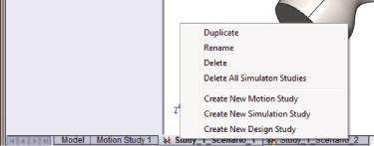

(b)

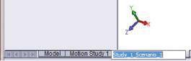

##### Fig u r e 2.45

*Renaming an existing study. (a) Starting the pop-up menu; (b) writing the new name.*

(a) (b)

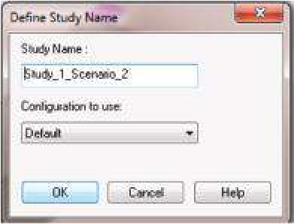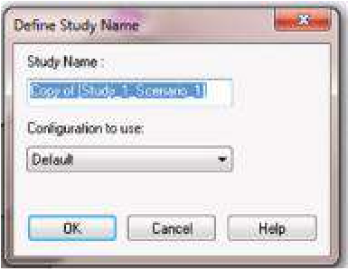

##### Figure 2.46

*Duplicating an existing study. (a) Define Study Name property manager before writing the name of the new study; (b) define Study Name property manager after writing the name of the new study.*

Before continuing with the input of the new loads, we delete the applied forces that are transferred to **Study_1_Scenario_2** through (Figure 2.47):

External Loads →Force-1(right click) →Delete ()

Now, we can continue with introduction of the loads from the **second scenario** following the consequence:

* Introducing a uniform pressure over a section of the side edge of the chisel and over its cutting face is done through the path

Fixtures →External Loads →Pressure()

To input the pressure on the bottom side of the chisel, the following stages must be fulfilled:

* Open the **Pressure** property manager – Right click on the **External loads** and pick **Pressure** in the newly opened window (1, Figure 2.48a).
* Open the **Split** property manager – Click the **Split** tab (2a, Figure 2.48b). Click the **Create Sketch** button to draw a sketch to split the selected face (2b, Figure 2.48b).
* Generate the sketch to be used to split the face – Use the **Sketch** toolbar, particularly the **Line** icon (, 3a, Figure 2.48c), to draw a quadrilateral with vertexes at the mid points of the sides and the vertexes of the face (3b, Figure 2.48c). Switch off the **Exit Sketch** button (3c, Figure 2.48c).

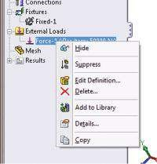

##### Fig u r e 2.47

*Deleting an exiting external load.*

(a) (b)

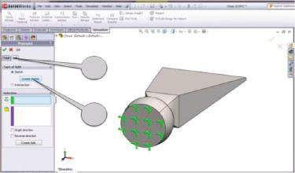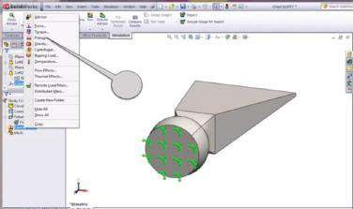

1

2

a

2

b

(c) (d)

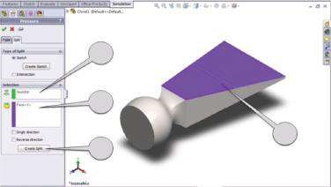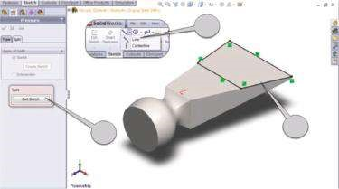

3

b

3

c

3

a

4

a

4

b*

4

c

4

b

(e) (f)

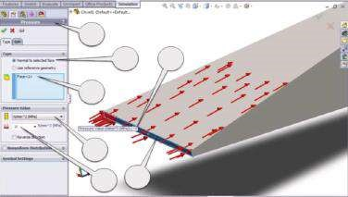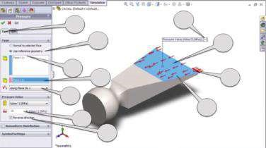

6

a

6

b

6

e*

5

f*

5

e*

d*

5

5

c*

5

a

5

b

5

e

5

f

5

g

5

c

d

5

6

c*

6

d

6

c

6

e

##### Figure 2.48

*Introducing both pressure loads – second scenario. (a) Starting of the Pressure property manager; (b) split property m anager; (c) generation of the sketch to be split; (d) splitting the face; (e) defining the pressure over the split face; (f) defining the pressure over the cutting face.*

* Split the face – The drawn sketch automatically appears in the **Contour** window (4a, Figure 2.48d); then click the face to be split (4b, Figure 2.48d) and the software colours it in violet, while its signature automatically appears in the violet window at the left (4b*, Figure 2.48d). Finally, click the **Create Split** button (4c, Figure 2.48d).
* Define the pressure over the split entity – Click the **Type** tab (5a, Figure 2.48e). As the pressure will be tangent to the face, select **Use reference geometry** (5b, Figure 2.48e). Pick the section of the face to be loaded directly in the **Graphics area** (5c, Figure 2.48e); it colours in blue and its signature is automatically written in the blue window on the left (5c*, Figure 2.48e).
* Define a reference entity – Select the same face by clicking on it (5d, Figure 2.48e) and it is directly accepted by the program as a reference entity, whose signature is in the pink window on the left (5d*, Figure 2.48e). Then introduce

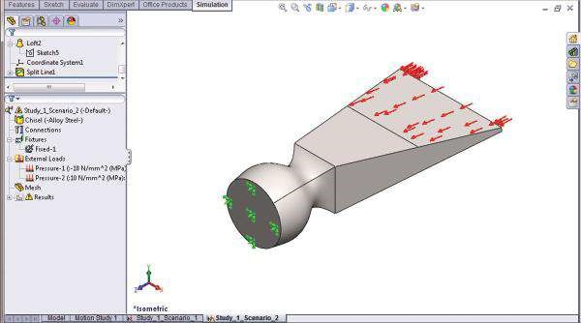

##### Fig u r e 2.49

*Pre-processed model of the chisel – second scenario.*

the direction of the pressure by selecting the **Along Plane Dir 2** option (5e, Figure 2.48e), and the direction of the symbols changes as it should be (5e*, Figure 2.48e). Introduce the value of 10 MPa (5f and 5f*, Figure 2.48e). Pick the **Reverse Direction** button to select the correct direction of the pressure (5g, Figure 2.48e). Click **OK** to confirm the input pressure.

* Define the pressure over the cutting face – Open the **Pressure** property manager (1, Figure 2.48a and 6a, Figure 2.48f). Select the option **Normal to selected face** (6b, Figure 2.48f). Click the loaded face in the **Graphics area** (6c and 6c*, Figure 2.48f). Choose the units – MPa (6d, Figure 2.48f) – and introduce the value of the pressure, which is assumed to be equal to 10 (6e and 6e*, Figure 2.48f). There is no need to select the **Reverse Direction** button. By default, the **Normal to selected face** loads point at the face.
* Click **OK** to close the **Pressure** property manager.

Starting the processing model of the chisel of scenario 2 is shown in Figure 2.49.

We studied different types of loads and how to start the Loads property managers. We commented on how the loads are applied to the model and what is the difference between Force and Pressure loads.

|  |
| --- |
| We have learnt how to   * Start Loads property manager * Introduce force and pressure loads * Introduce loads on the entire entity or how to split the entity if necessary * Define uniform and non-uniform loads |